|  |
| --- |
| Photo displaying partial image of two pie charts on a canvas-textured page |
| AZURE 201  PROJECT CASE STUDY REPORT |
| |  |  |  | | --- | --- | --- | | Mayank Singh Rathore | 5/14/20 | [Course title] | |

Contents

I. PROBLEM STATEMENTS 2

II. BACKGROUND 3

**A. Microsoft Azure** 3

**B. Azure Resource Manager Templates/ARM Templates** 3

**C. Storage Account** 3

1. AZURE STORAGE 5

ARM Template 5

Steps and Screens 6

2. AZURE VIRTUAL NETWORKS AND VIRTUAL MACHINES 9

ARM Template 9

Steps and Screens 10

ARM Template 13

Steps and Screens 14

Steps and Screens 17

3. AZURE APP SERVICES 20

Steps and Screens 20

4. AZURE FUNCTIONS 25

ARM Template 25

Steps and Screens 26

5. AZURE COSMOS DB 30

ARM Template 30

6. BIBLIOGRAPHY 34

**References** 34

**Project Source Code** 34

# I. PROBLEM STATEMENTS

This project case study covers series of assignments that would help participants to learn and demonstrate Azure Cloud Platform ecosystem and its features.

**For each of the listed assignment, build/implement your solution and submit your solution with appropriate screen capture along with steps you had followed to implement.**

**Azure Storage**

1. Write a template to create a Storage Account with SKU restrictions, encryption enabled and allow https access only.

**Azure Virtual Networks and Virtual Machines**

1. Create an ARM Template for a virtual network with subnets and Network Security Group with Inbound Outbound rules.

2. Write an ARM Template to deploy a Windows VM using the existing VNets and NSGs.

3. Deploy an application in the VM and access using the public IP.

**Azure App Services**

1. Deploy a HTML Web Application in Azure App Services.

2. Host the App Services in the Virtual Machine deployed.

**Azure Functions**

1. Write an ARM Template to deploy the azure function along with the code and other required configurations.

**Azure Cosmos DB**

1. Write an ARM Template to deploy all the Cosmos DBs.

2. Integrate the above deployed Azure function with all the Cosmos DB and retrieve the logs.

**Azure Active Directory**

1. Write a client application to authenticate based on OAuth grant flow.

# II. BACKGROUND

## **A. Microsoft Azure**

Azure is an ever-expanding set of cloud services offered by Microsoft to help organizations meet business challenges. It allows building, managing and deploying applications on a massive, global network using tools and frameworks depending on the business needs.

## **B. Azure Resource Manager Templates/ARM Templates**

Requests to Azure are managed using an API. Originally, it was managed using the Azure Service Management API or ASM, which control deployments of what is termed “Classic”. This was replaced by the **Azure Resource Manager** or **ARM API**. The resources that the ARM API manages are objects in Azure such as network cards, virtual machines, hosted databases.

The main benefits of the ARM API are that you can deploy several resources together in a single unit and that the deployments are idempotent, in that the user declares the type of resource, what name to use and which properties it should have; the ARM API will then either create a new object that matches those details or change an existing object which has the same name and type to have the same properties.

ARM Templates are a way to declare the objects you want, the types, names and properties in a JSON file which can be checked into source control and managed like any other code file. ARM Templates are what really gives us the ability to roll out Azure “**Infrastructure as code**”.

Source:

<https://www.red-gate.com/simple-talk/cloud/infrastructure-as-a-service/azure-resource-manager-arm-templates/>

## **C. Storage Account**

An Azure storage account contains all of your Azure Storage data objects: blobs, files, queues, tables, and disks. The storage account provides a unique namespace for your Azure Storage data that is accessible from anywhere in the world over HTTP or HTTPS. Data in your Azure storage account is durable and highly available, secure, and massively scalable.

Azure Storage offers several types of storage accounts. Each type supports different features and has its own pricing model. Consider these differences before you create a storage account to determine the type of account that is best for your applications. The types of storage accounts are:

* **General-purpose v2 accounts**:

Basic storage account type for blobs, files, queues, and tables. Recommended for most scenarios using Azure Storage.

* **General-purpose v1 accounts**:

Legacy account type for blobs, files, queues, and tables. Use general-purpose v2 accounts instead when possible.

* **BlockBlobStorage accounts**:

Storage accounts with premium performance characteristics for block blobs and append blobs. Recommended for scenarios with high transactions rates, or scenarios that use smaller objects or require consistently low storage latency.

* **FileStorage accounts**:

Files-only storage accounts with premium performance characteristics. Recommended for enterprise or high performance scale applications.

* **BlobStorage accounts**:

Legacy Blob-only storage accounts. Use general-purpose v2 accounts instead when possible.

Source: <https://docs.microsoft.com/en-us/azure/storage/common/storage-account-overview>

# 1. AZURE STORAGE

**WRITE A TEMPLATE TO CREATE A STORAGE ACCOUNT WITH SKU RESTRICTIONS, ENCRYPTION ENABLED AND ALLOW HTTPS ACCESS ONLY**

## ARM Template

{

  "$schema": "http://schema.management.azure.com/schemas/2015-01-01/deploymentTemplate.json#",

  "contentVersion": "1.0.0.0",

  "parameters": {},

  "resources": [

      {

  "name": "201encstorageaccount",

  "type": "Microsoft.Storage/storageAccounts",

  "apiVersion": "2019-04-01",

  "sku": {

    "name": "Standard_LRS"

  },

  "kind": "StorageV2",

  "location": "[resourceGroup().location]",

  "tags": {},

  "identity": {

    "type": "SystemAssigned"

  },

  "properties": {

    "encryption": {

        "keySource": "Microsoft.Storage",

      "services": {

        "blob": {

          "enabled": "true"

        },

        "file": {

          "enabled": "true"

        }

      }

    },

    "supportsHttpsTrafficOnly": "true",

    "isHnsEnabled": "false",

    "largeFileSharesState": "enabled"

  },

  "resources": []

}

  ]

}

## Steps and Screens

Step #1: Create an ARM template with appropriate name at **Azure Portal/Templates** with the above JSON content.

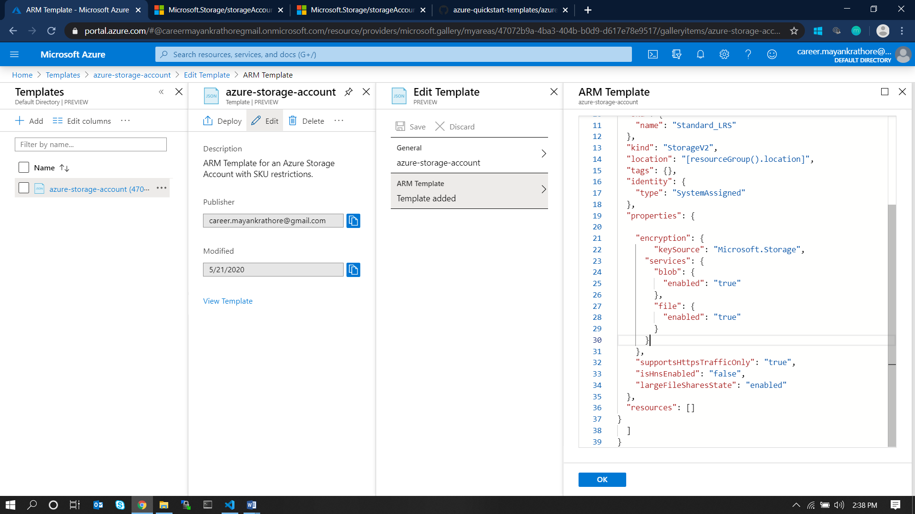

Step #2: Accept to Terms and Conditions and Deploy the template by clicking on Purchase.

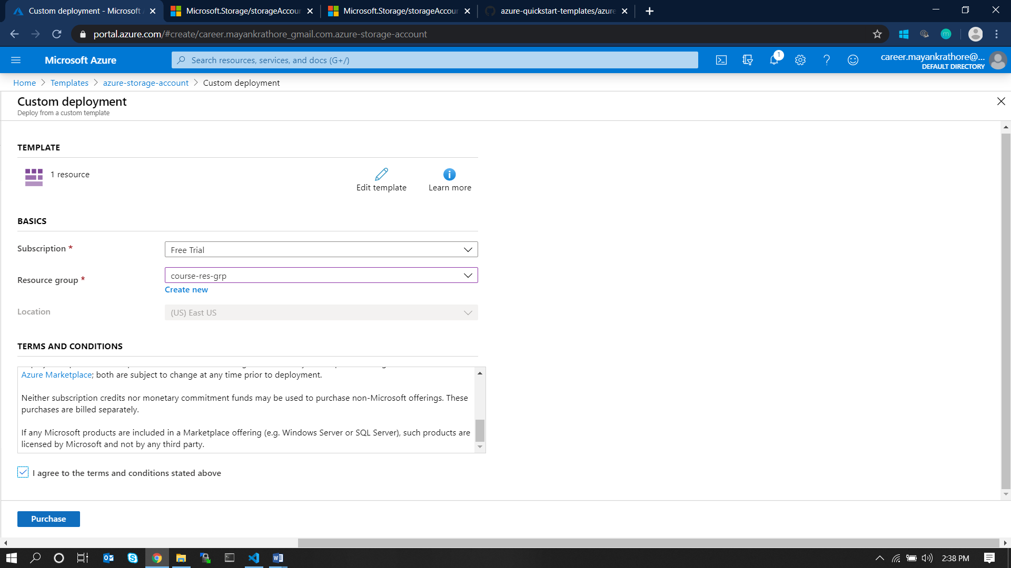

Step #3: Click on the activity logs to view progress.

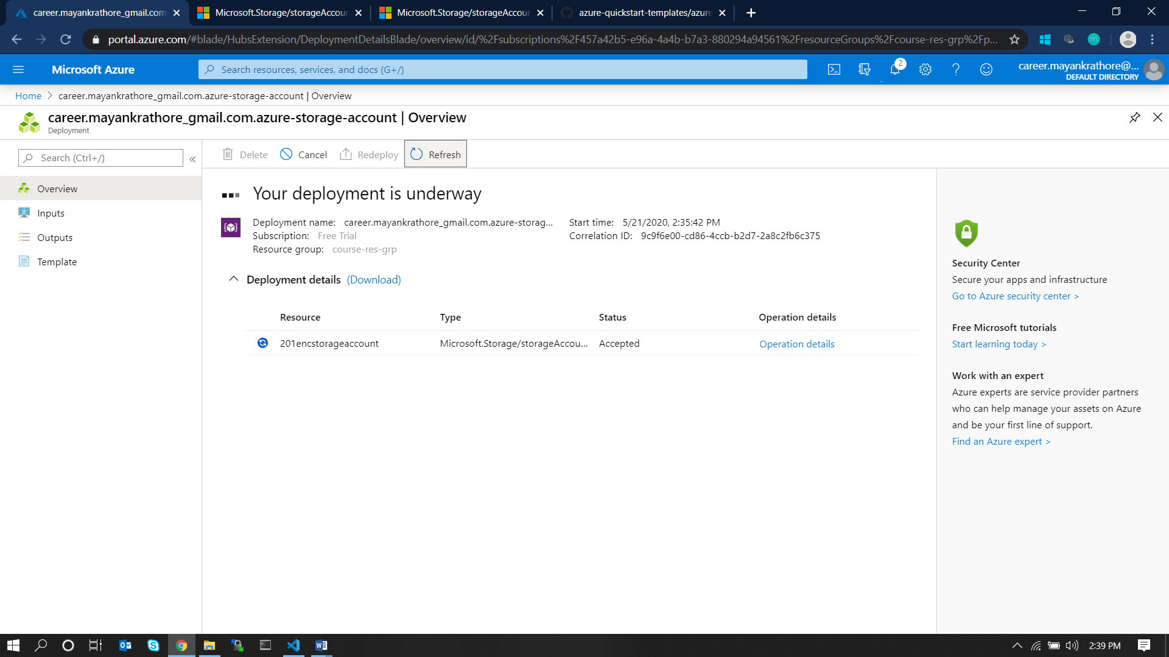

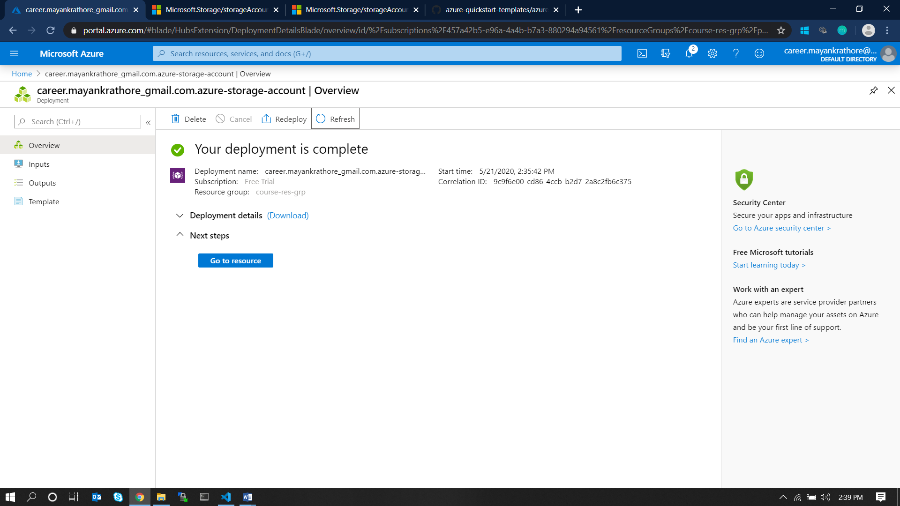

Step #4: Browse the created storage account in portal at AzurePortal/Storage Accounts

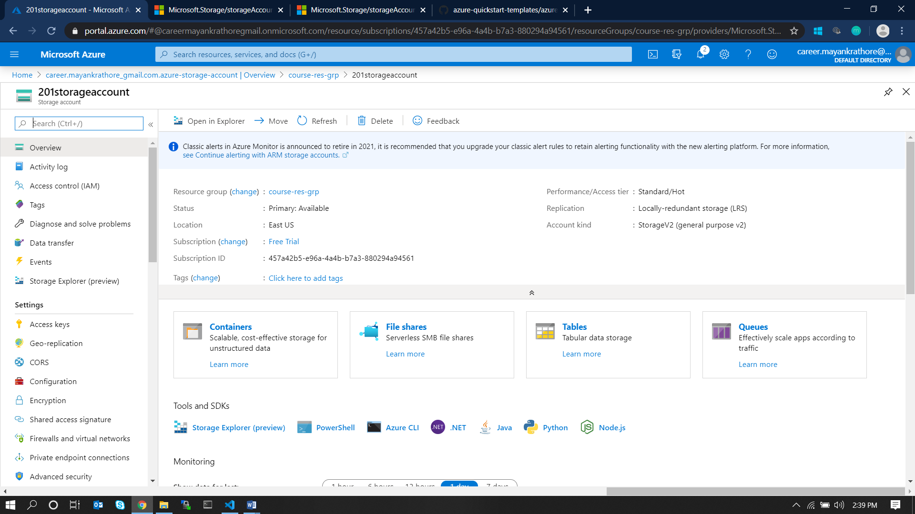

Step #5: Cleanup

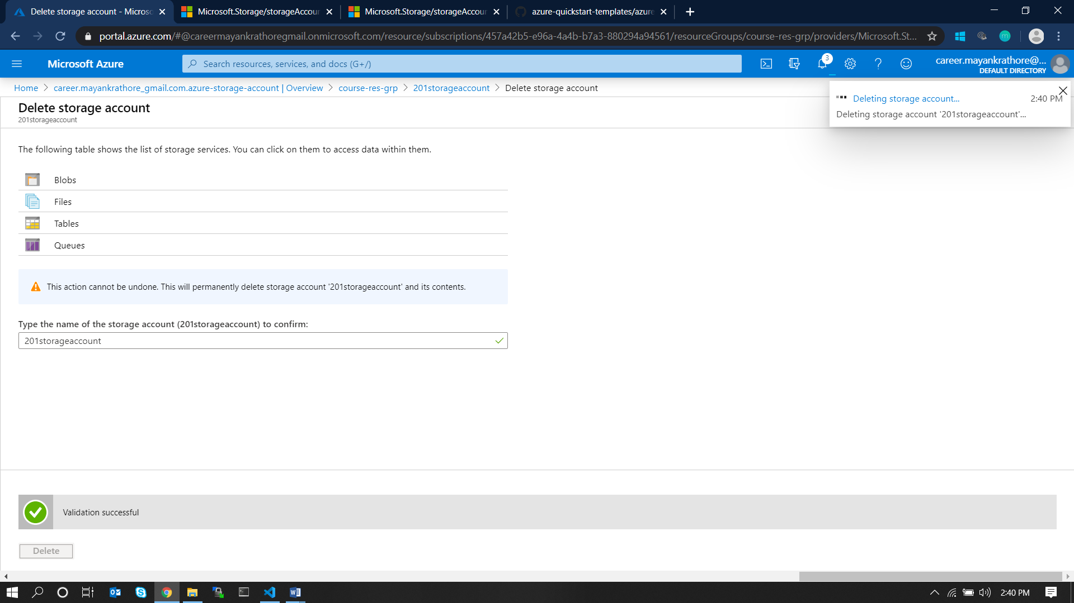

# 2. AZURE VIRTUAL NETWORKS AND VIRTUAL MACHINES

**1. Create an ARM Template for a virtual network with subnets and Network Security Group with Inbound Outbound rules.**

## ARM Template

{

  "$schema": "https://schema.management.azure.com/schemas/2015-01-01/deploymentTemplate.json#",

  "contentVersion": "1.0.0.0",

  "parameters": {

    "nsgName": {

      "type": "string"

    }

  },

  "variables": {

    "VNETPrefix": "10.0.0.0/16",

    "VNETSubnet1Name": "201subnet1",

    "VNETSubnet1Prefix": "10.0.0.0/24",

    "VNETSubnet2Name": "201subnet2",

    "VNETSubnet2Prefix": "10.0.1.0/24"},

  "resources": [

    {

      "name": "VNET",

      "type": "Microsoft.Network/virtualNetworks",

      "location": "[resourceGroup().location]",

      "apiVersion": "2016-03-30",

      "dependsOn": [

        "[resourceId('Microsoft.Network/networkSecurityGroups',parameters('nsgName'))]"

      ],

      "tags": {

        "displayName": "VNET"

      },

      "properties": {

        "addressSpace": {

          "addressPrefixes": [

            "[variables('VNETPrefix')]"

          ]

        },

        "subnets": [

          {

            "name": "[variables('VNETSubnet1Name')]",

            "properties": {

              "addressPrefix": "[variables('VNETSubnet1Prefix')]",

              "networkSecurityGroup": {

                "id": "[resourceId('Microsoft.Network/networkSecurityGroups', parameters('nsgName'))]"

              }

            }

          },

          {

            "name": "[variables('VNETSubnet2Name')]",

            "properties": {

              "addressPrefix": "[variables('VNETSubnet2Prefix')]"

            }

          }

        ]

      }

    },

    {

      "type": "Microsoft.Network/networkSecurityGroups",

      "name": "[parameters('nsgName')]",

      "apiVersion": "2018-02-01",

      "location": "[resourceGroup().location]",

      "dependsOn": [],

      "properties": {

        "securityRules": [

          {

            "name": "inbound-tcp-80-http",

            "etag": "W/\"0e74bdd1-2fa9-46e6-98f6-d7e82c81cba2\"",

            "properties": {

              "protocol": "Tcp",

              "sourcePortRange": "*",

              "destinationPortRange": "80",

              "sourceAddressPrefix": "*",

              "destinationAddressPrefix": "VirtualNetwork",

              "access": "Allow",

              "priority": 100,

              "direction": "Inbound",

              "sourcePortRanges": [],

              "destinationPortRanges": [],

              "sourceAddressPrefixes": [],

              "destinationAddressPrefixes": []

            }

          }

        ],

        "defaultSecurityRules": [

          {

            "name": "AllowVnetInBound",

            "etag": "W/\"0e74bdd1-2fa9-46e6-98f6-d7e82c81cba2\"",

            "properties": {

              "description": "Allow inbound traffic from all VMs in VNET",

              "protocol": "*",

              "sourcePortRange": "*",

              "destinationPortRange": "*",

              "sourceAddressPrefix": "VirtualNetwork",

              "destinationAddressPrefix": "VirtualNetwork",

              "access": "Allow",

              "priority": 65000,

              "direction": "Inbound",

              "sourcePortRanges": [],

              "destinationPortRanges": [],

              "sourceAddressPrefixes": [],

              "destinationAddressPrefixes": []

            }

          },

          {

            "name": "AllowAzureLoadBalancerInBound",

            "etag": "W/\"0e74bdd1-2fa9-46e6-98f6-d7e82c81cba2\"",

            "properties": {

              "description": "Allow inbound traffic from azure load balancer",

              "protocol": "*",

              "sourcePortRange": "*",

              "destinationPortRange": "*",

              "sourceAddressPrefix": "AzureLoadBalancer",

              "destinationAddressPrefix": "*",

              "access": "Allow",

              "priority": 65001,

              "direction": "Inbound",

              "sourcePortRanges": [],

              "destinationPortRanges": [],

              "sourceAddressPrefixes": [],

              "destinationAddressPrefixes": []

            }

          },

          {

            "name": "DenyAllInBound",

            "etag": "W/\"0e74bdd1-2fa9-46e6-98f6-d7e82c81cba2\"",

            "properties": {

              "description": "Deny all inbound traffic",

              "protocol": "*",

              "sourcePortRange": "*",

              "destinationPortRange": "*",

              "sourceAddressPrefix": "*",

              "destinationAddressPrefix": "*",

              "access": "Deny",

              "priority": 65500,

              "direction": "Inbound",

              "sourcePortRanges": [],

              "destinationPortRanges": [],

              "sourceAddressPrefixes": [],

              "destinationAddressPrefixes": []

            }

          },

          {

            "name": "AllowVnetOutBound",

            "etag": "W/\"0e74bdd1-2fa9-46e6-98f6-d7e82c81cba2\"",

            "properties": {

              "description": "Allow outbound traffic from all VMs to all VMs in VNET",

              "protocol": "*",

              "sourcePortRange": "*",

              "destinationPortRange": "*",

              "sourceAddressPrefix": "VirtualNetwork",

              "destinationAddressPrefix": "VirtualNetwork",

              "access": "Allow",

              "priority": 65000,

              "direction": "Outbound",

              "sourcePortRanges": [],

              "destinationPortRanges": [],

              "sourceAddressPrefixes": [],

              "destinationAddressPrefixes": []

            }

          },

          {

            "name": "AllowInternetOutBound",

            "etag": "W/\"0e74bdd1-2fa9-46e6-98f6-d7e82c81cba2\"",

            "properties": {

              "description": "Allow outbound traffic from all VMs to Internet",

              "protocol": "*",

              "sourcePortRange": "*",

              "destinationPortRange": "*",

              "sourceAddressPrefix": "*",

              "destinationAddressPrefix": "Internet",

              "access": "Allow",

              "priority": 65001,

              "direction": "Outbound",

              "sourcePortRanges": [],

              "destinationPortRanges": [],

              "sourceAddressPrefixes": [],

              "destinationAddressPrefixes": []

            }

          },

          {

            "name": "DenyAllOutBound",

            "etag": "W/\"0e74bdd1-2fa9-46e6-98f6-d7e82c81cba2\"",

            "properties": {

              "description": "Deny all outbound traffic",

              "protocol": "*",

              "sourcePortRange": "*",

              "destinationPortRange": "*",

              "sourceAddressPrefix": "*",

              "destinationAddressPrefix": "*",

              "access": "Deny",

              "priority": 65500,

              "direction": "Outbound",

              "sourcePortRanges": [],

              "destinationPortRanges": [],

              "sourceAddressPrefixes": [],

              "destinationAddressPrefixes": []

            }

          }

        ]

      }

    }

  ],

  "outputs": {

    "VNET-ResourceID": {

      "type": "string",

      "value":"[resourceid('Microsoft.Network/virtualNetworks','vnet')]"

    }

  }

}

## Steps and Screens

Step #1: Create an ARM template with appropriate name at **Azure Portal/Templates** with the above JSON content.

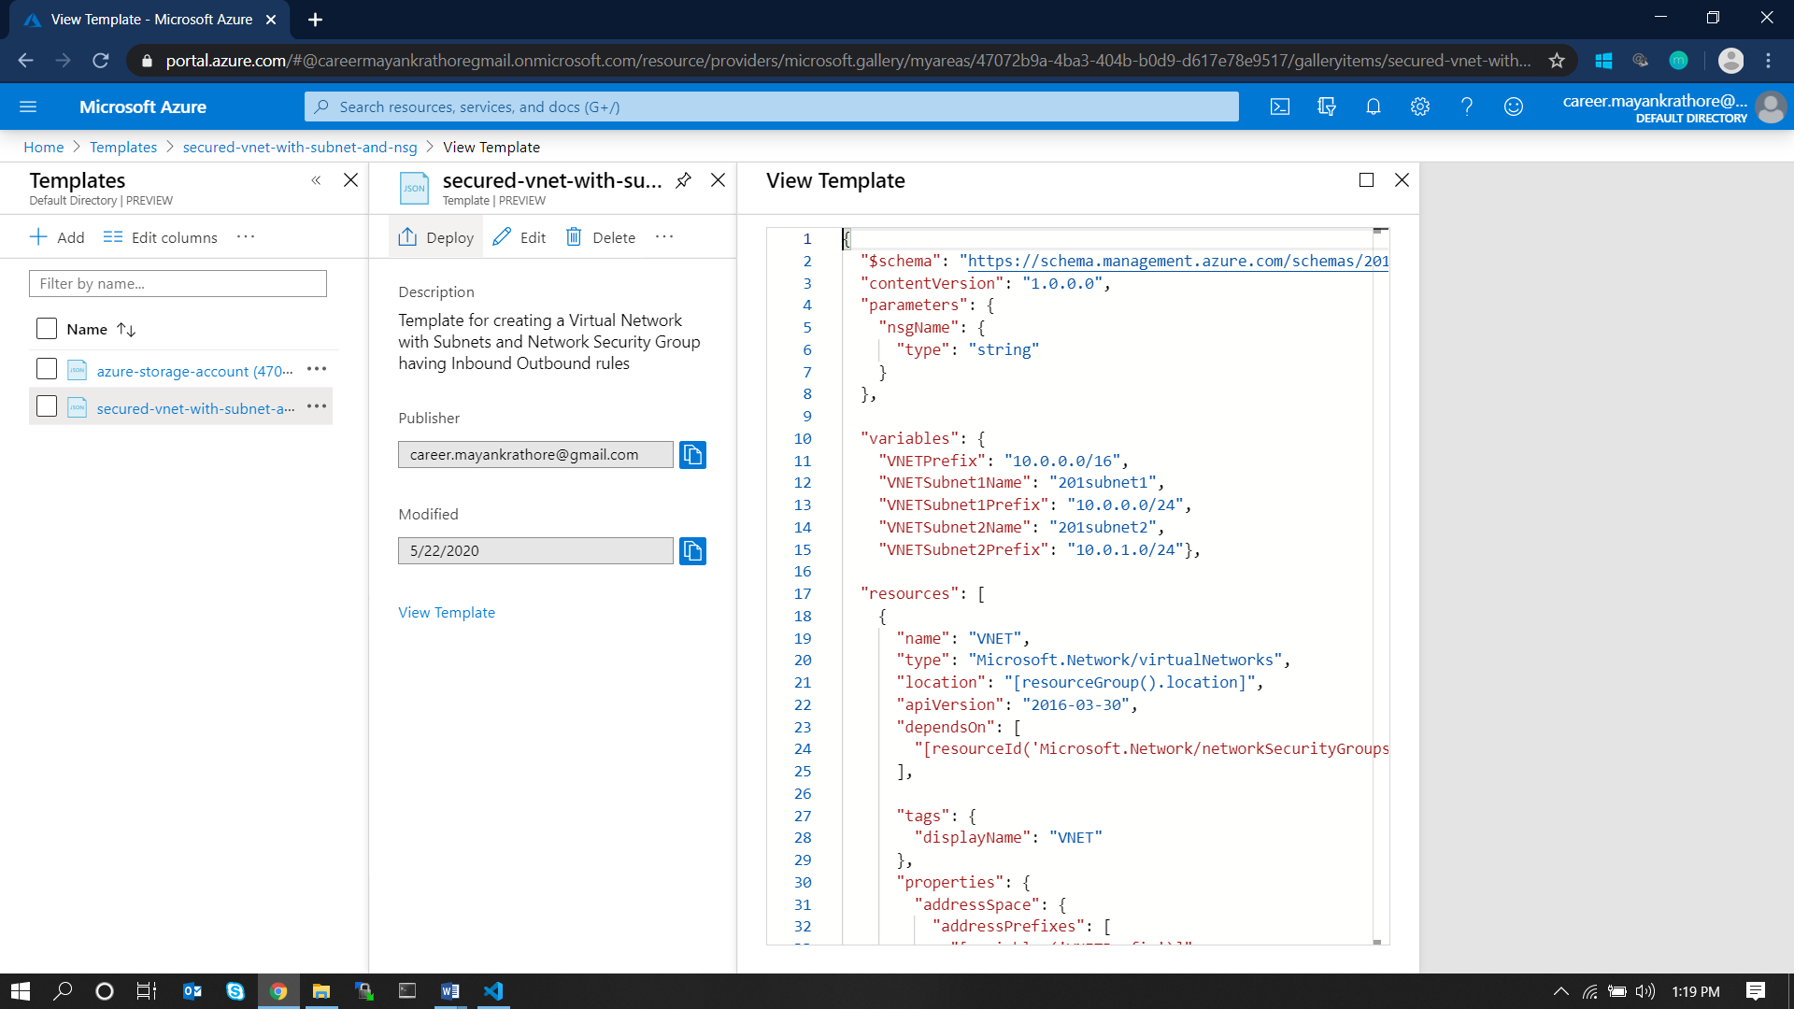

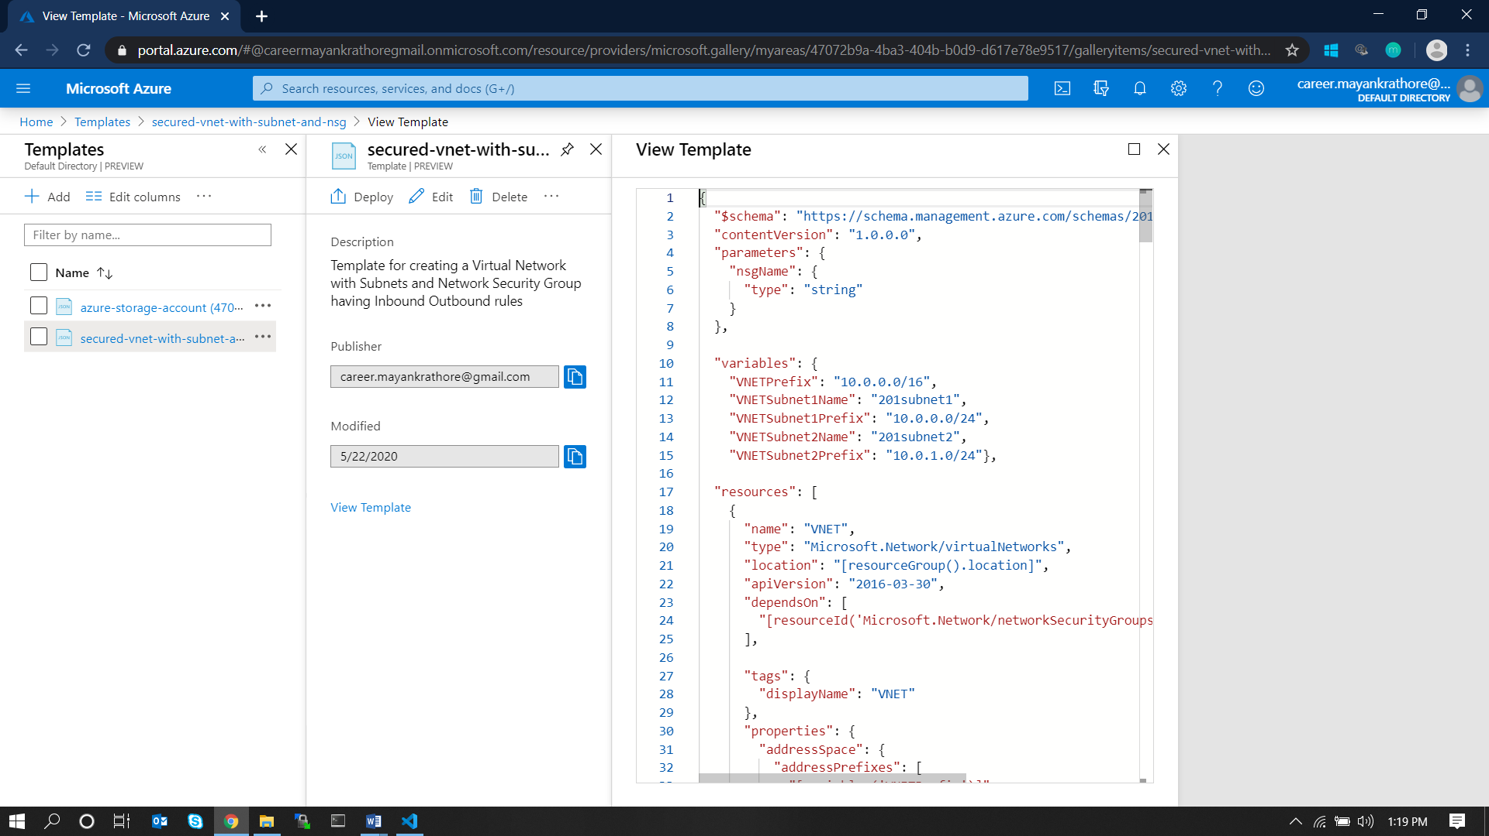

Step #2: Accept to Terms and Conditions and Deploy the template by clicking on Purchase.

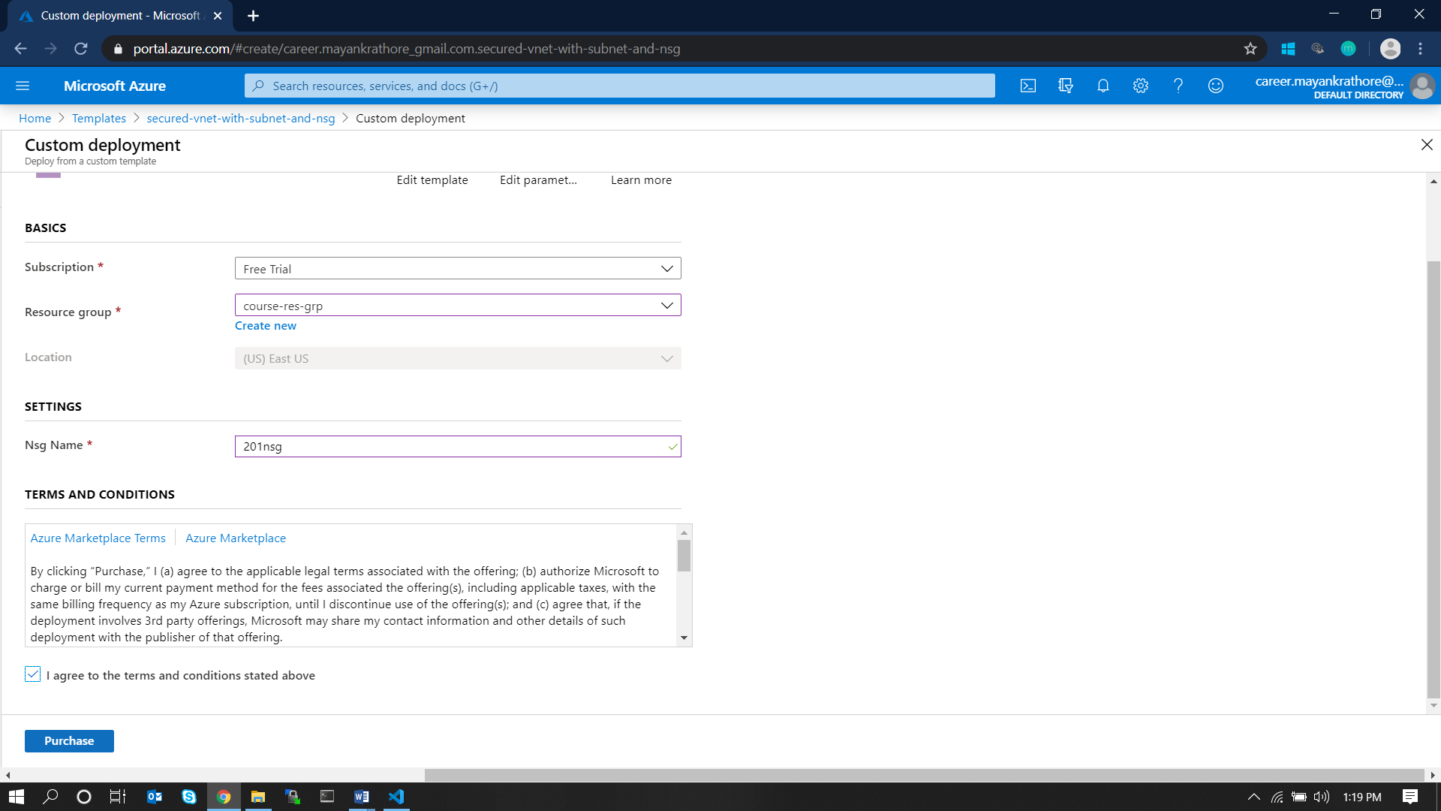

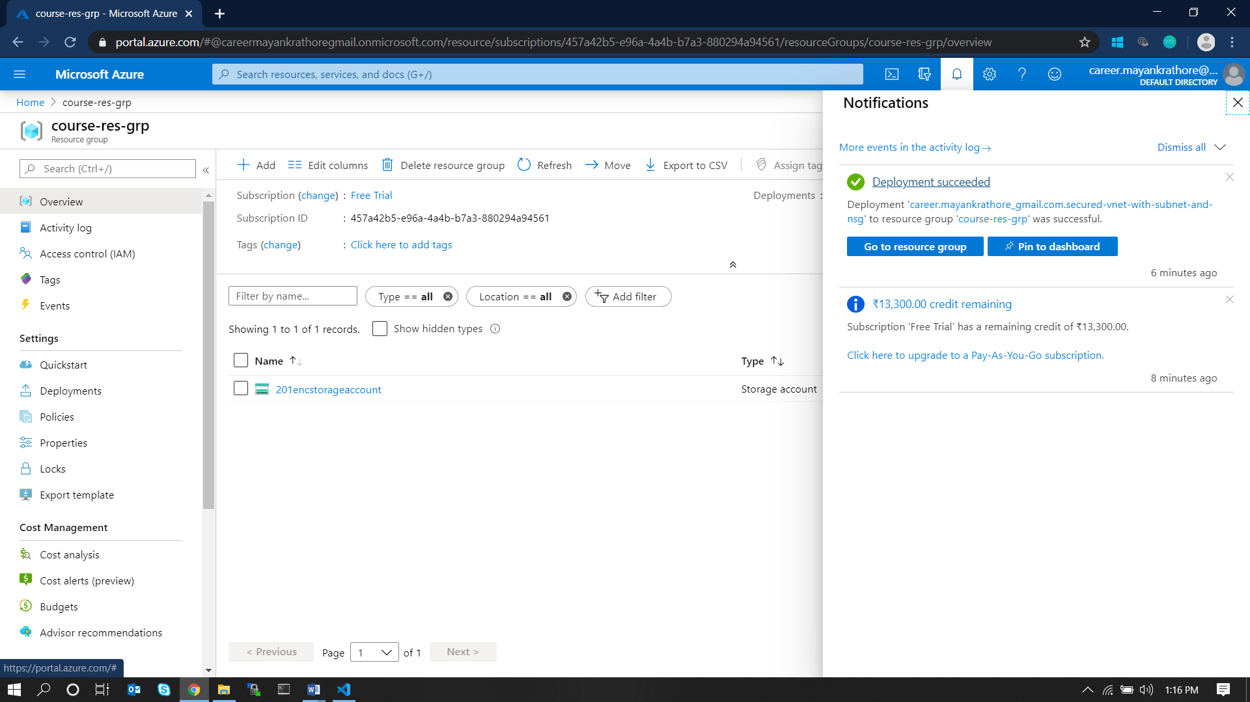

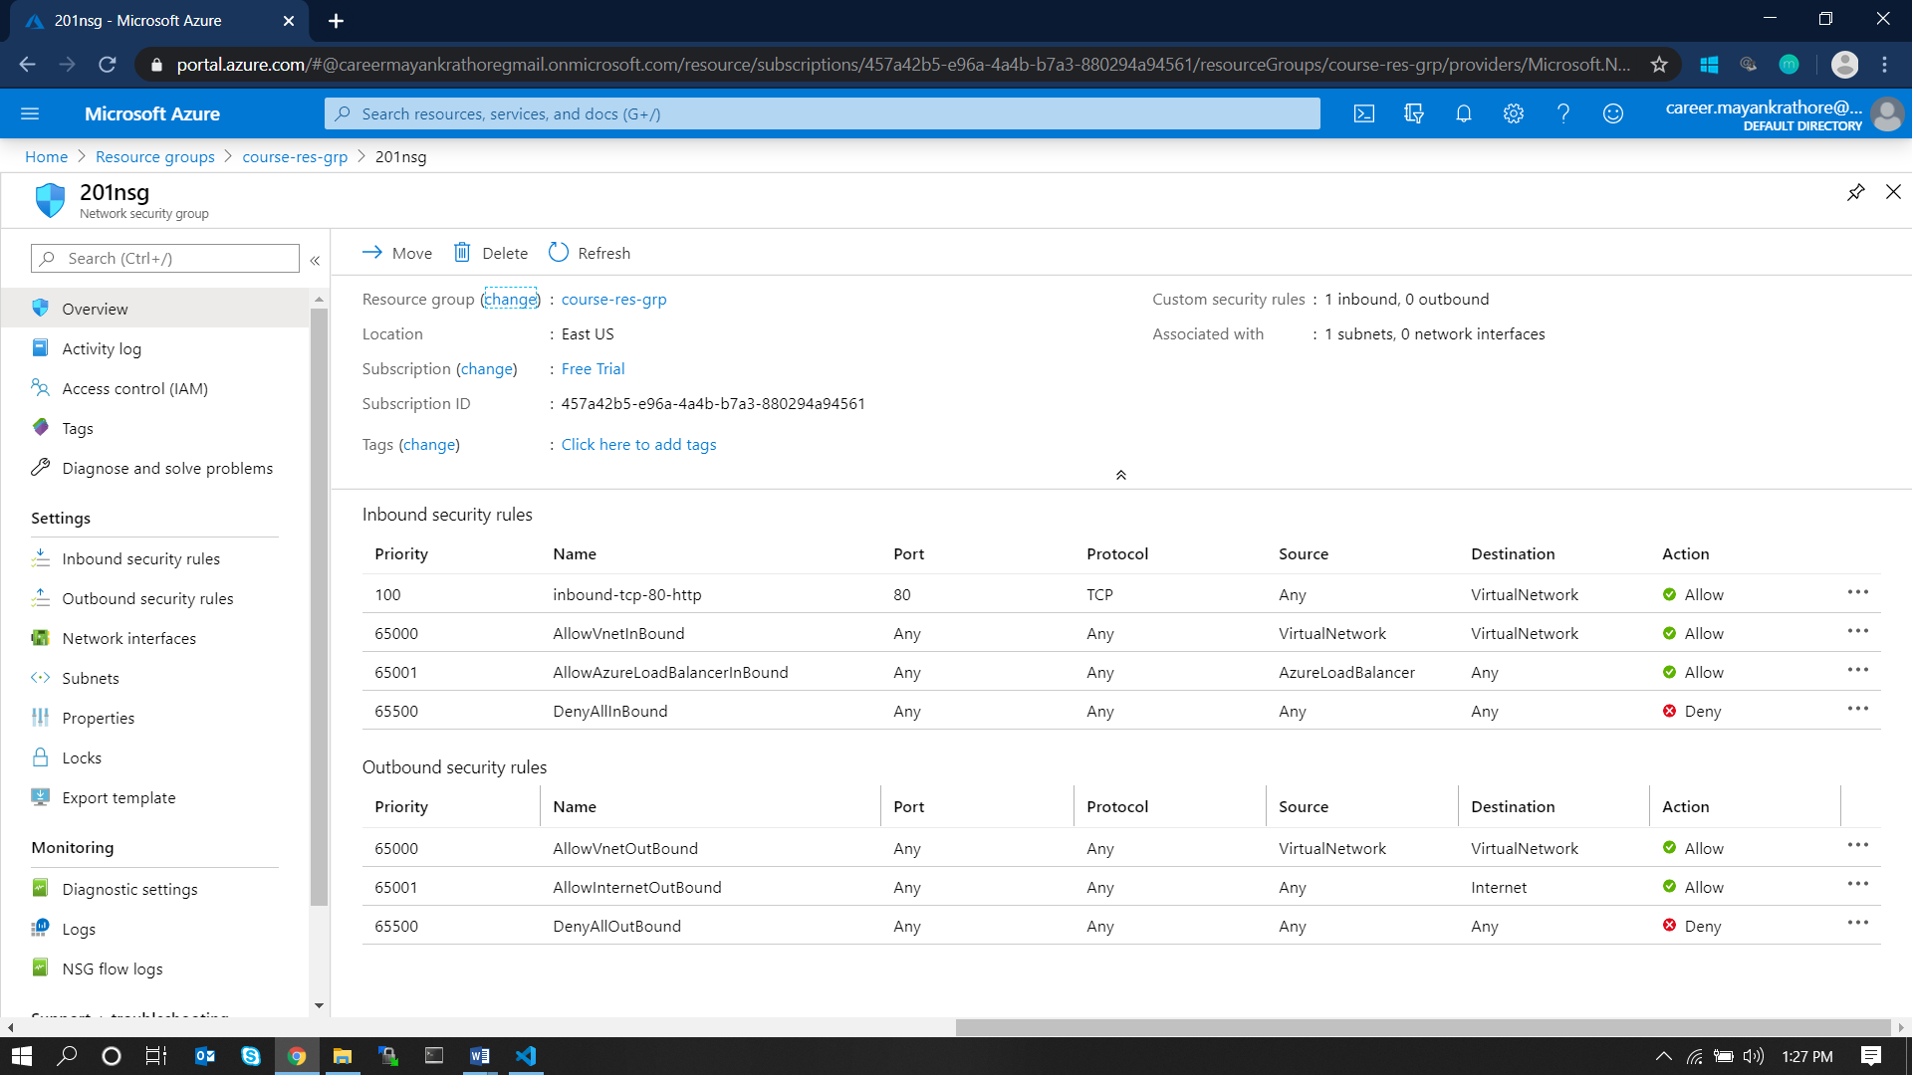

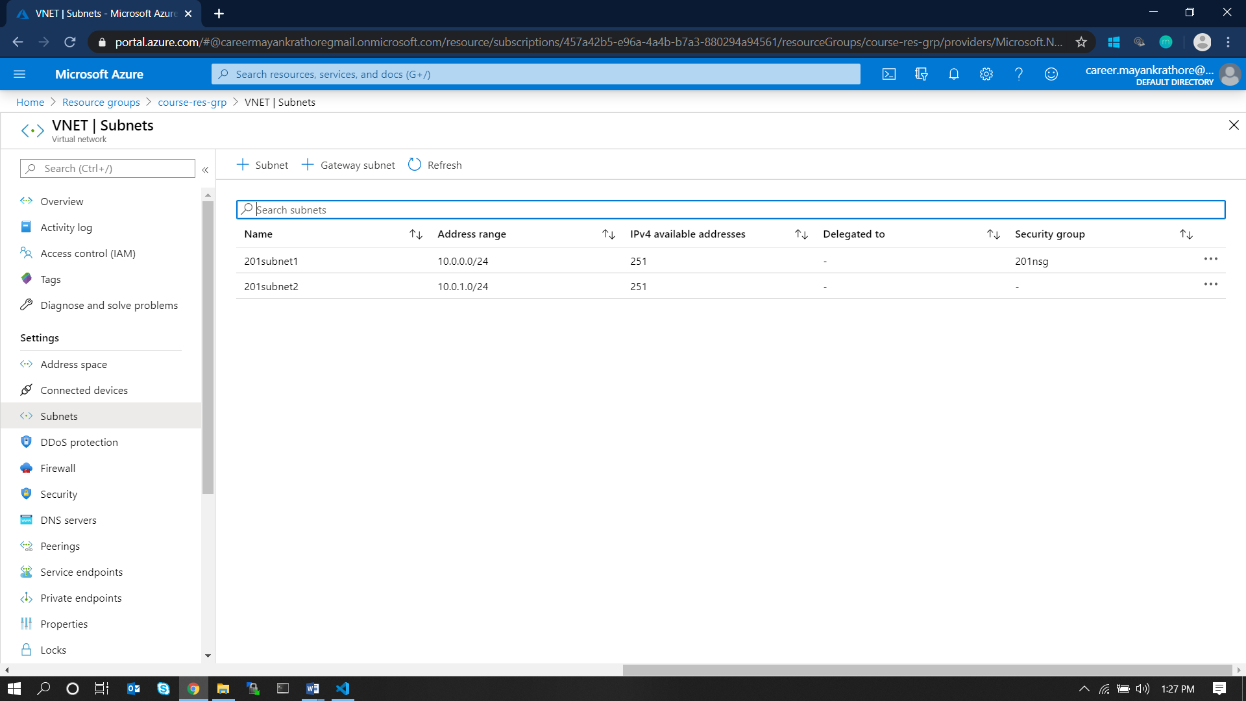

**2. Write an ARM Template to deploy a Windows VM using the existing VNets and NSGs.**

## ARM Template

{

    "$schema": "https://schema.management.azure.com/schemas/2015-01-01/deploymentTemplate.json#",

    "contentVersion": "1.0.0.0",

    "parameters": {

        "adminUsername": {

            "type": "string",

            "metadata": {

                "description": "Username for the Virtual Machine."

            }

        },

        "adminPassword": {

            "type": "securestring",

            "metadata": {

                "description": "Password for the Virtual Machine."

            }

        },

        "dnsLabelPrefix": {

            "type": "string",

            "metadata": {

                "description": "Unique DNS Name for the Public IP used to access the Virtual Machine."

            }

        },

        "windowsOSVersion": {

            "type": "string",

            "defaultValue": "2016-Datacenter",

            "allowedValues": [

                "2008-R2-SP1",

                "2012-Datacenter",

                "2012-R2-Datacenter",

                "2016-Nano-Server",

                "2016-Datacenter-with-Containers",

                "2016-Datacenter",

                "2019-Datacenter"

            ],

            "metadata": {

                "description": "The Windows version for the VM. This will pick a fully patched image of this given Windows version."

            }

        },

        "location": {

            "type": "string",

            "defaultValue": "[resourceGroup().location]",

            "metadata": {

                "description": "Location for all resources."

            }

        }

    },

    "variables": {

        "storageAccountName": "[concat(uniquestring(resourceGroup().id), 'sawinvm')]",

        "nicName": "myVMNic",

        "addressPrefix": "10.0.0.0/16",

        "subnetName": "201subnet1",

        "subnetPrefix": "10.0.0.0/24",

        "publicIPAddressName": "myPublicIP",

        "vmName": "SimpleWinVM",

        "virtualNetworkName": "VNET",

        "subnetRef": "[resourceId('Microsoft.Network/virtualNetworks/subnets', variables('virtualNetworkName'), variables('subnetName'))]"

    },

    "resources": [

        {

            "type": "Microsoft.Storage/storageAccounts",

            "apiVersion": "2018-11-01",

            "name": "[variables('storageAccountName')]",

            "location": "[parameters('location')]",

            "sku": {

                "name": "Standard_LRS"

            },

            "kind": "Storage",

            "properties": {}

        },

        {

            "type": "Microsoft.Network/publicIPAddresses",

            "apiVersion": "2018-11-01",

            "name": "[variables('publicIPAddressName')]",

            "location": "[parameters('location')]",

            "properties": {

                "publicIPAllocationMethod": "Dynamic",

                "dnsSettings": {

                    "domainNameLabel": "[parameters('dnsLabelPrefix')]"

                }

            }

        },

        {

            "type": "Microsoft.Network/virtualNetworks",

            "apiVersion": "2018-11-01",

            "name": "[variables('virtualNetworkName')]",

            "location": "[parameters('location')]",

            "properties": {

                "addressSpace": {

                    "addressPrefixes": [

                        "[variables('addressPrefix')]"

                    ]

                },

                "subnets": [

                    {

                        "name": "[variables('subnetName')]",

                        "properties": {

                            "addressPrefix": "[variables('subnetPrefix')]"

                        }

                    }

                ]

            }

        },

        {

            "type": "Microsoft.Network/networkInterfaces",

            "apiVersion": "2018-11-01",

            "name": "[variables('nicName')]",

            "location": "[parameters('location')]",

            "dependsOn": [

                "[resourceId('Microsoft.Network/publicIPAddresses/', variables('publicIPAddressName'))]",

                "[resourceId('Microsoft.Network/virtualNetworks/', variables('virtualNetworkName'))]"

            ],

            "properties": {

                "ipConfigurations": [

                    {

                        "name": "ipconfig1",

                        "properties": {

                            "privateIPAllocationMethod": "Dynamic",

                            "publicIPAddress": {

                                "id": "[resourceId('Microsoft.Network/publicIPAddresses',variables('publicIPAddressName'))]"

                            },

                            "subnet": {

                                "id": "[variables('subnetRef')]"

                            }

                        }

                    }

                ]

            }

        },

        {

            "type": "Microsoft.Compute/virtualMachines",

            "apiVersion": "2018-10-01",

            "name": "[variables('vmName')]",

            "location": "[parameters('location')]",

            "dependsOn": [

                "[resourceId('Microsoft.Storage/storageAccounts/', variables('storageAccountName'))]",

                "[resourceId('Microsoft.Network/networkInterfaces/', variables('nicName'))]"

            ],

            "properties": {

                "hardwareProfile": {

                    "vmSize": "Standard_D2s_v3"

                },

                "osProfile": {

                    "computerName": "[variables('vmName')]",

                    "adminUsername": "[parameters('adminUsername')]",

                    "adminPassword": "[parameters('adminPassword')]"

                },

                "storageProfile": {

                    "imageReference": {

                        "publisher": "MicrosoftWindowsServer",

                        "offer": "WindowsServer",

                        "sku": "[parameters('windowsOSVersion')]",

                        "version": "latest"

                    },

                    "osDisk": {

                        "createOption": "FromImage"

                    },

                    "dataDisks": [

                        {

                            "diskSizeGB": 1023,

                            "lun": 0,

                            "createOption": "Empty"

                        }

                    ]

                },

                "networkProfile": {

                    "networkInterfaces": [

                        {

                            "id": "[resourceId('Microsoft.Network/networkInterfaces',variables('nicName'))]"

                        }

                    ]

                },

                "diagnosticsProfile": {

                    "bootDiagnostics": {

                        "enabled": true,

                        "storageUri": "[reference(resourceId('Microsoft.Storage/storageAccounts/', variables('storageAccountName'))).primaryEndpoints.blob]"

                    }

                }

            }

        }

    ],

    "outputs": {

        "hostname": {

            "type": "string",

            "value": "[reference(variables('publicIPAddressName')).dnsSettings.fqdn]"

        }

    }

}

## Steps and Screens

Step #1: Create an ARM template with appropriate name at **Azure Portal/Templates** with the above JSON content.

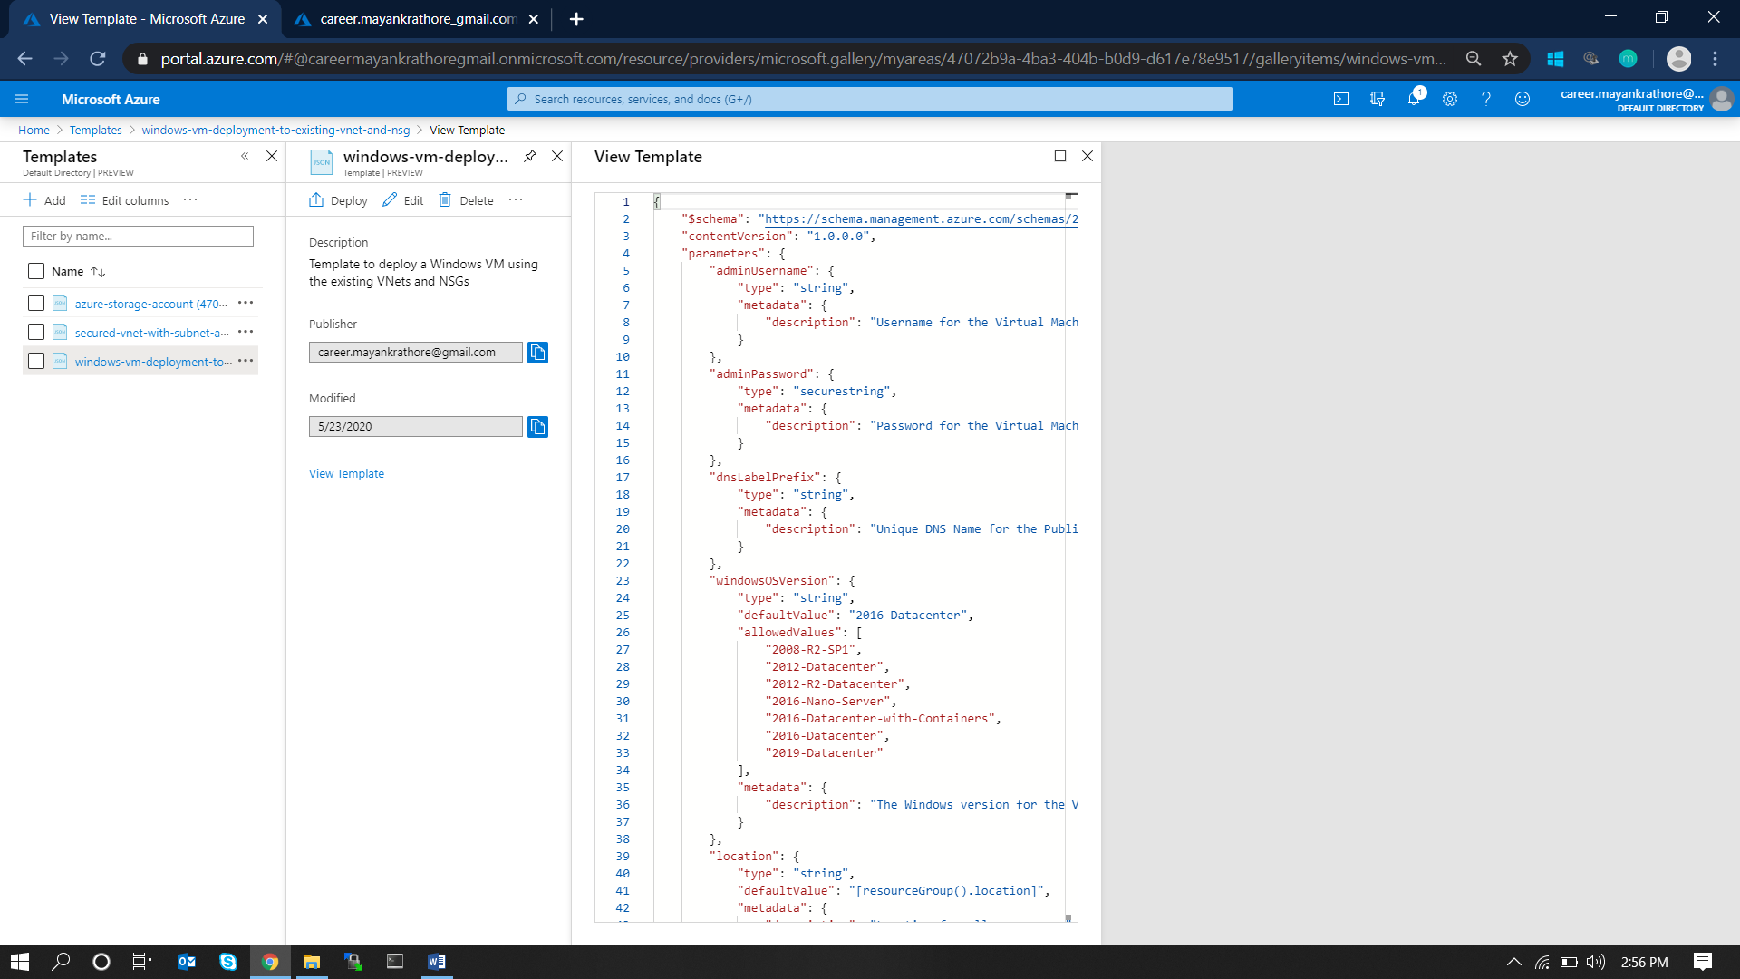

Step #2: Click on Deploy template to proceed with deployment.

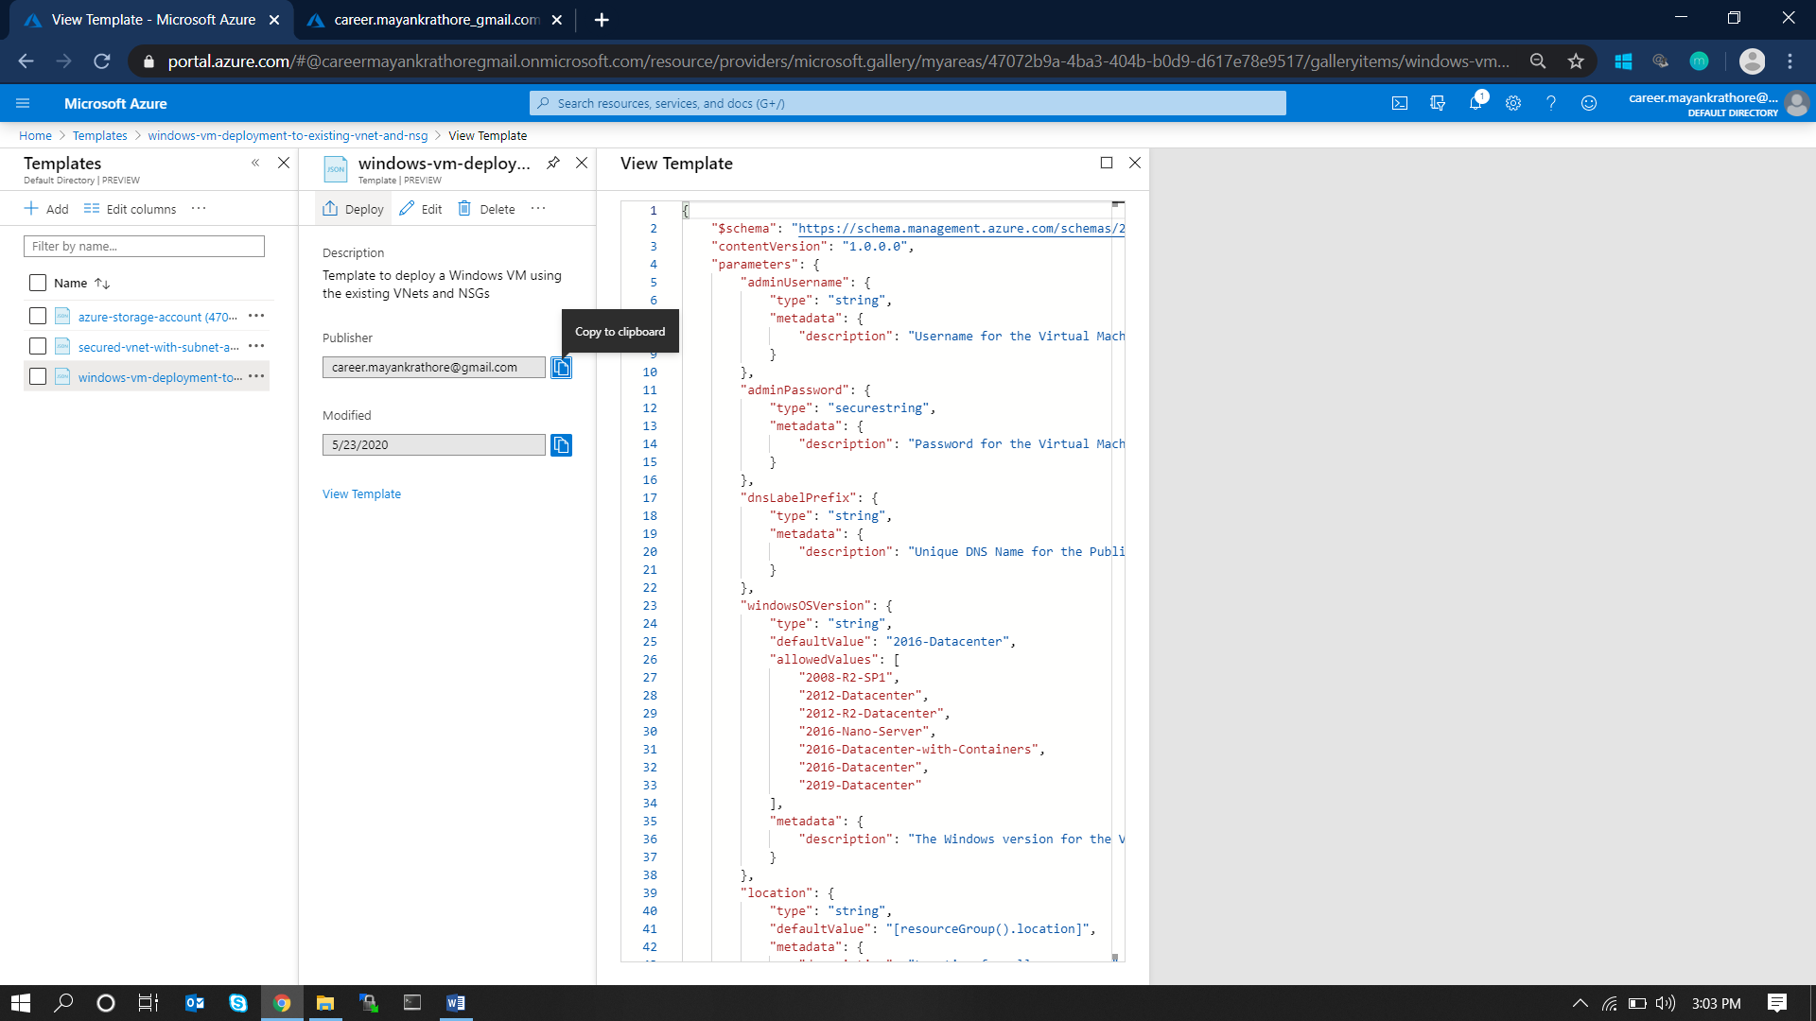

Step #3: Accept to Terms and Conditions and deploy the template by clicking on Purchase.

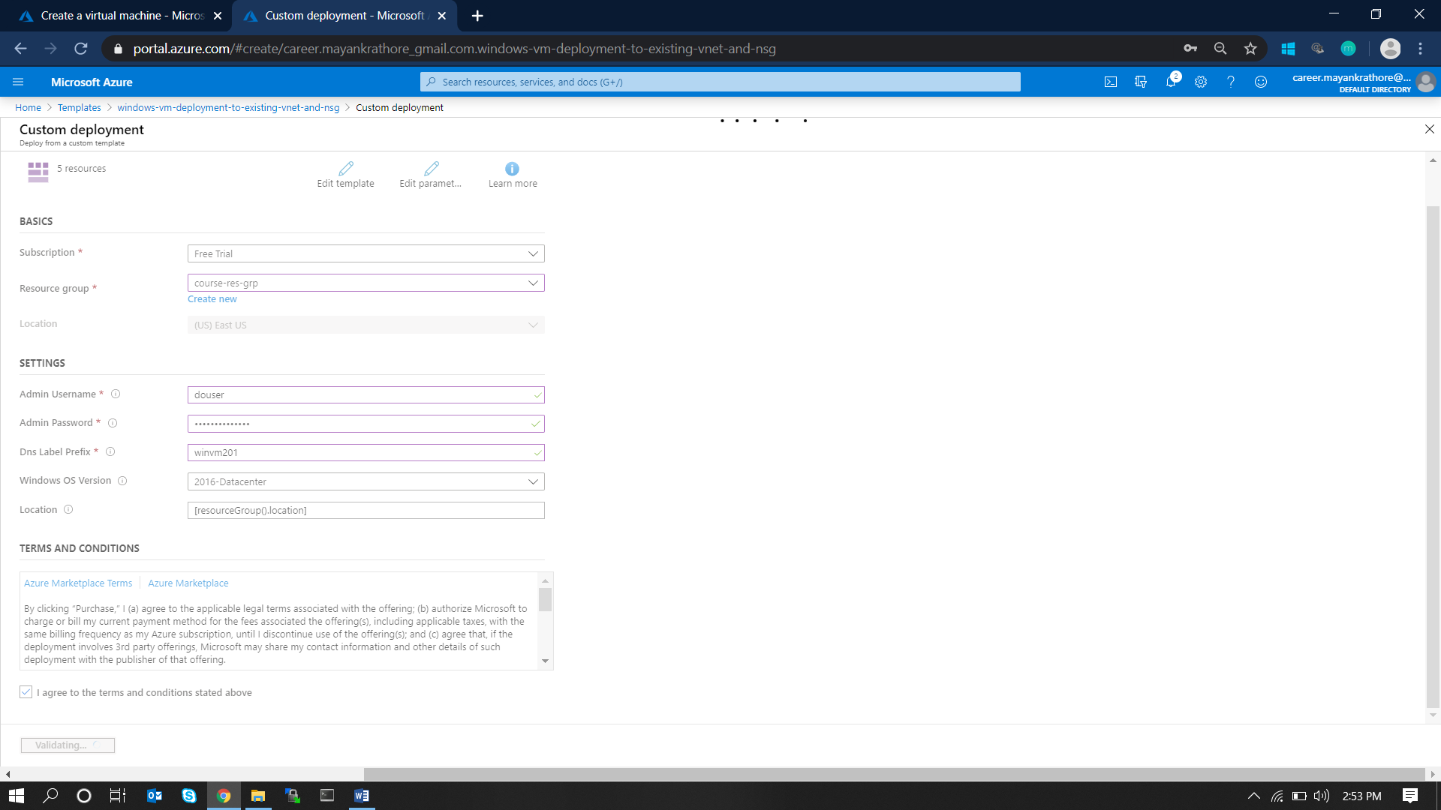

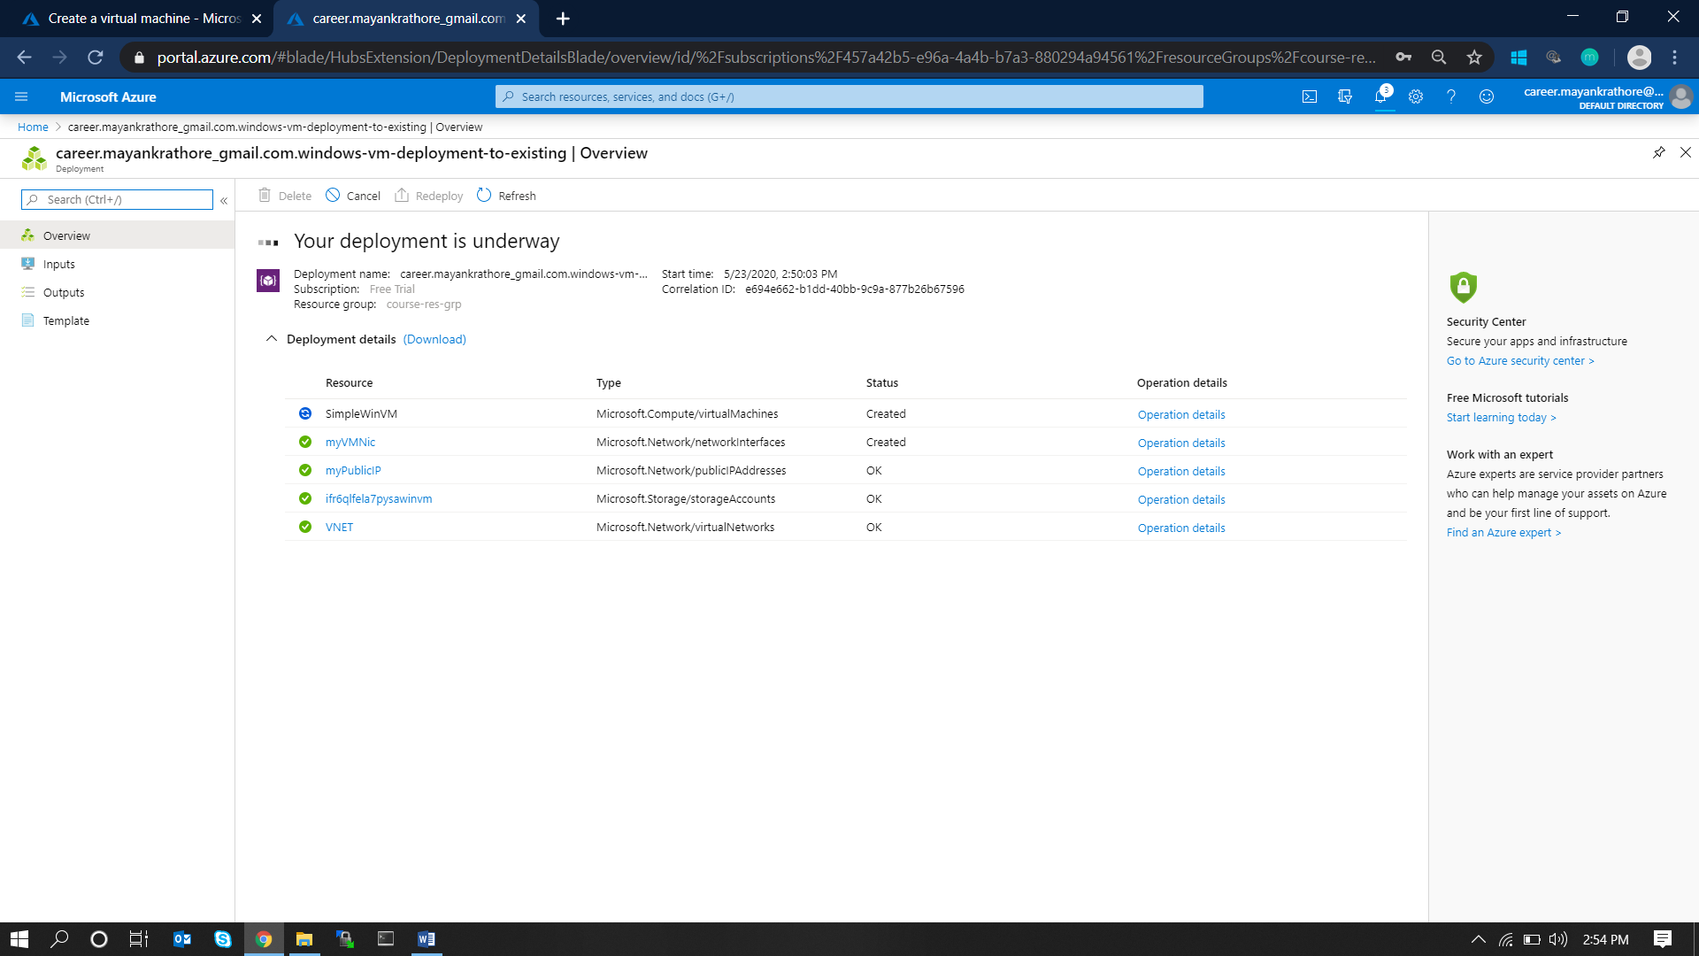

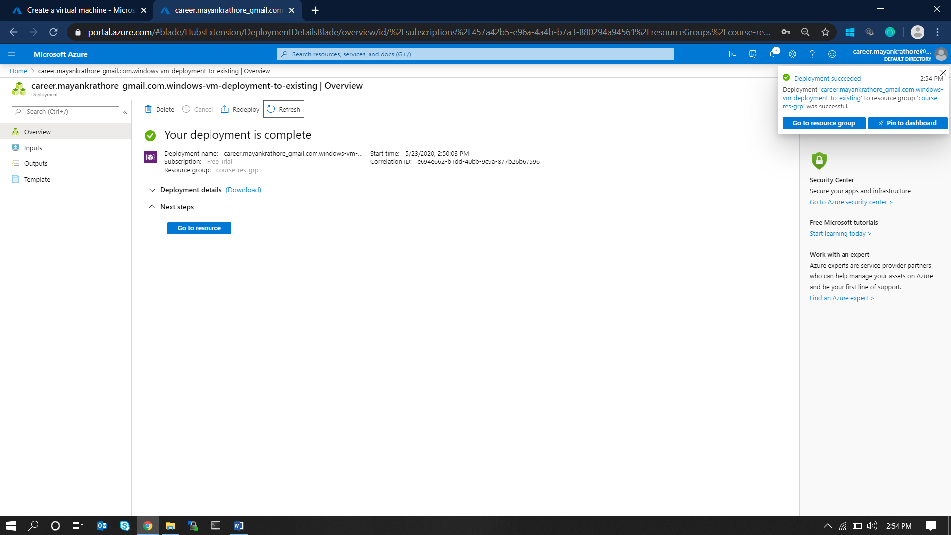

**3. Deploy an application in the VM and access using the public IP.**

## Steps and Screens

Step #1: Logging into the Virtual Machine – Go to AzurePortal/VirtualMachine and click on the VM created in the last step.

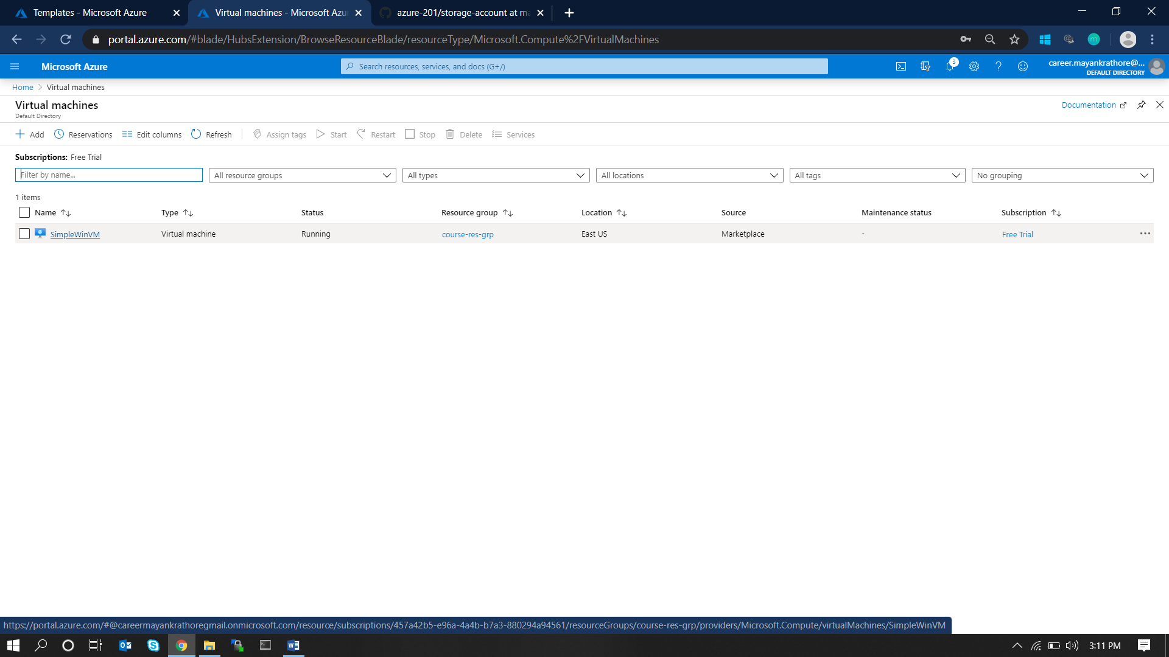

Step #2: Download the RDP file from connect tab and open it to connect to the VM

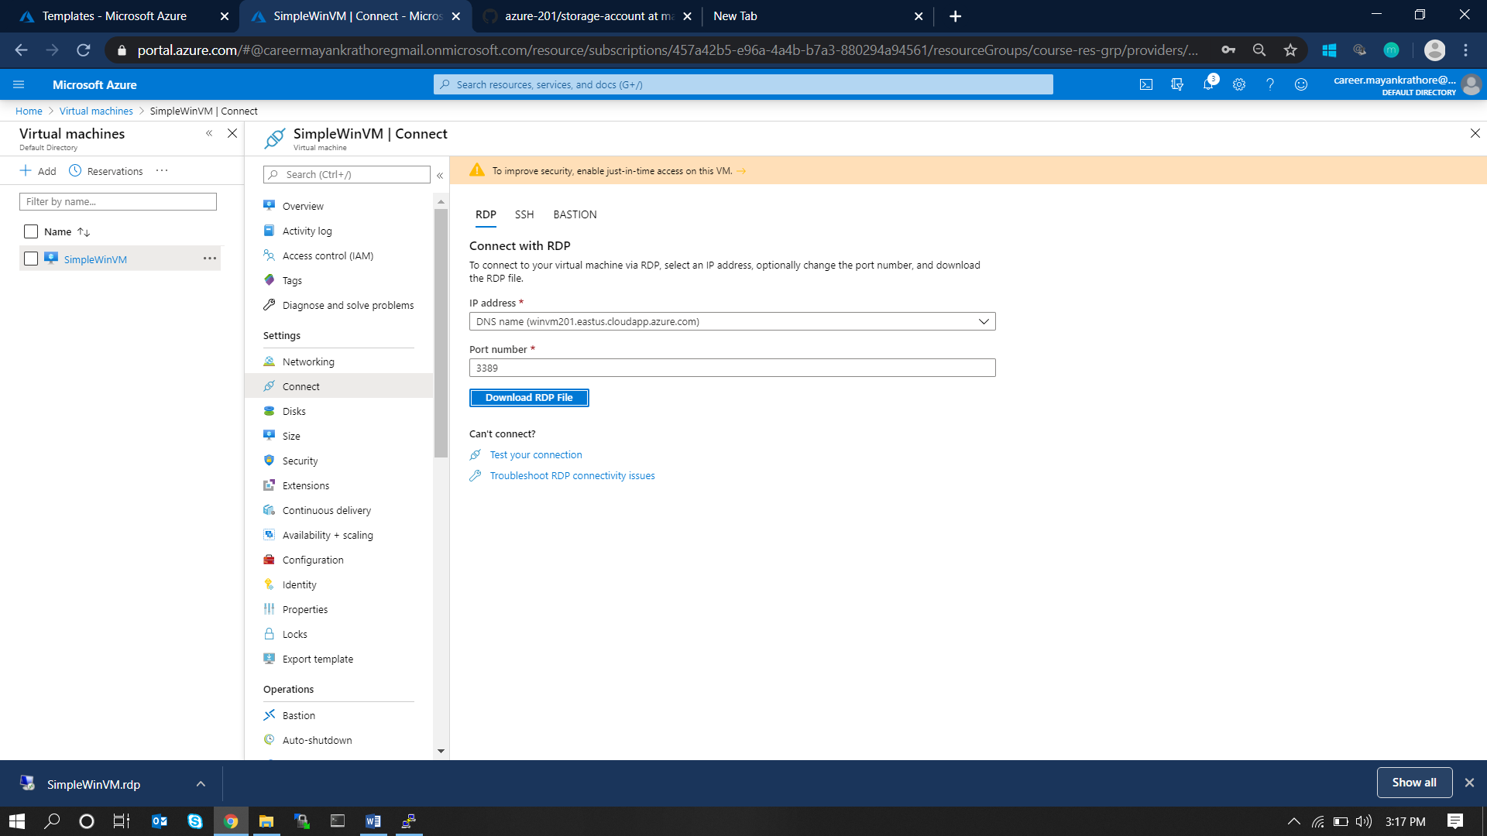

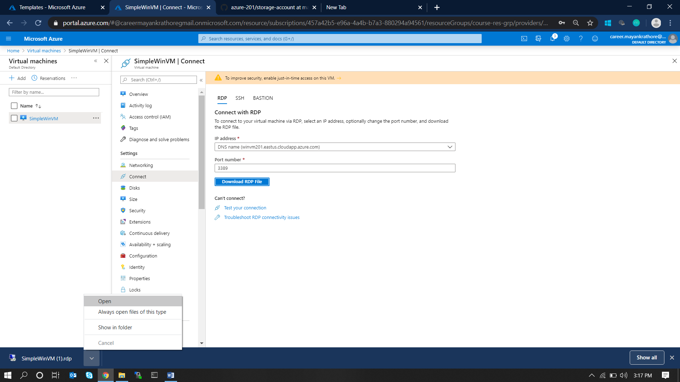

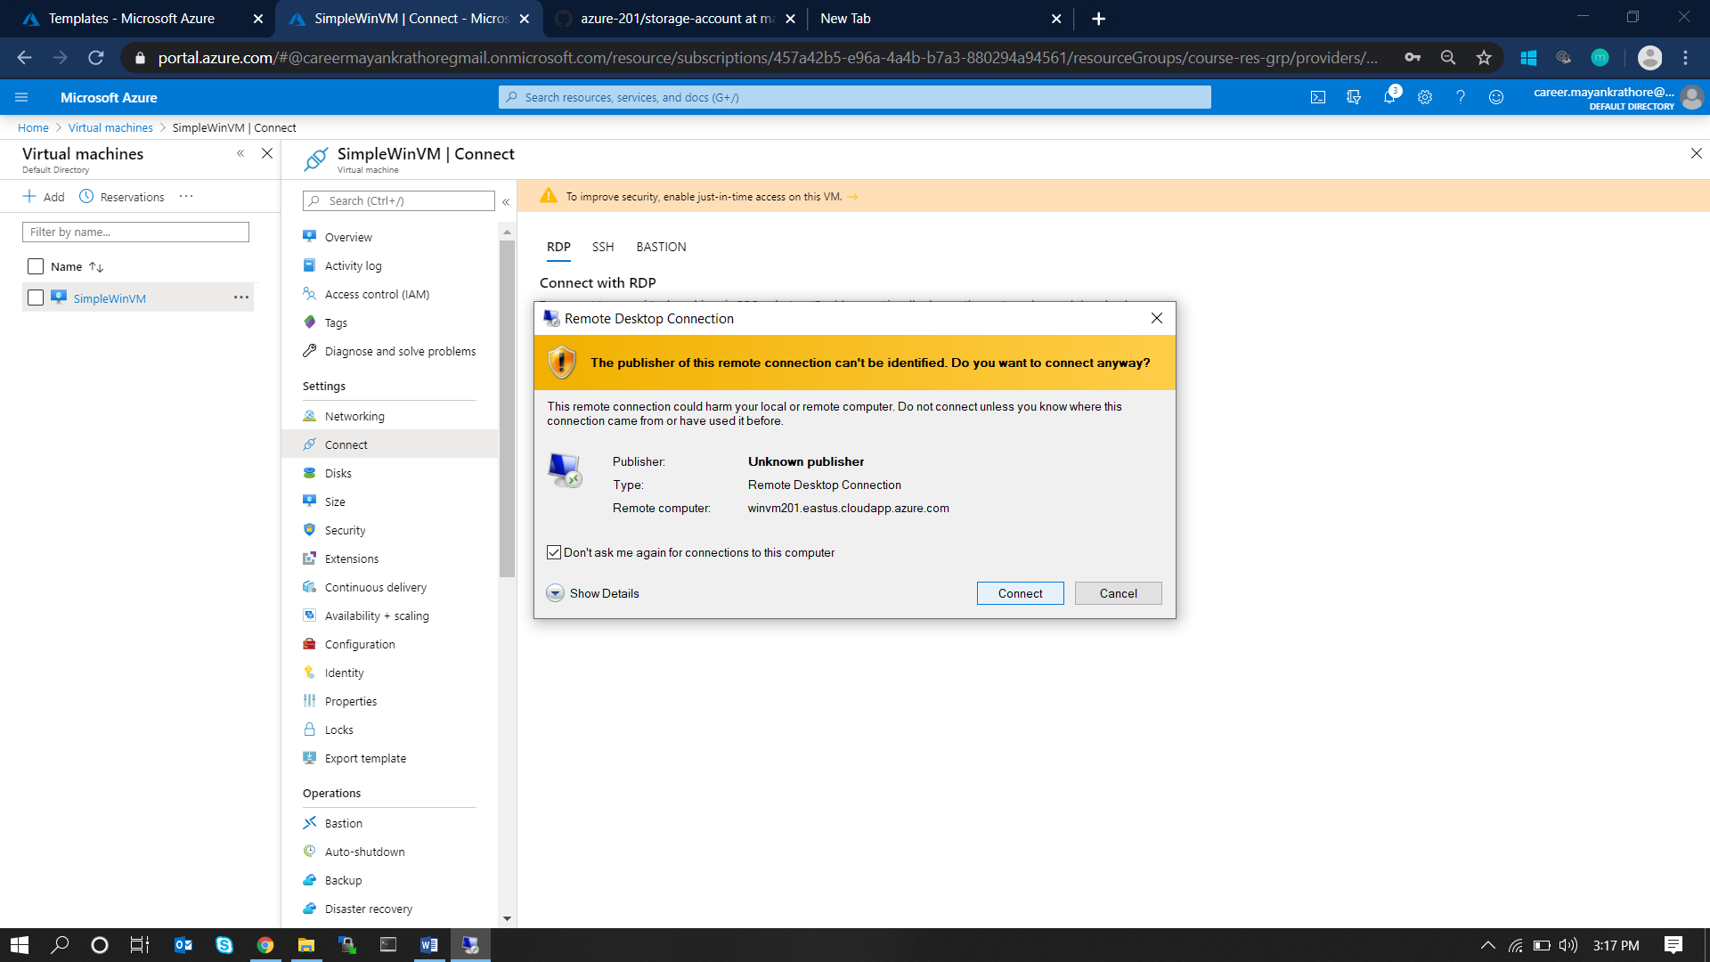

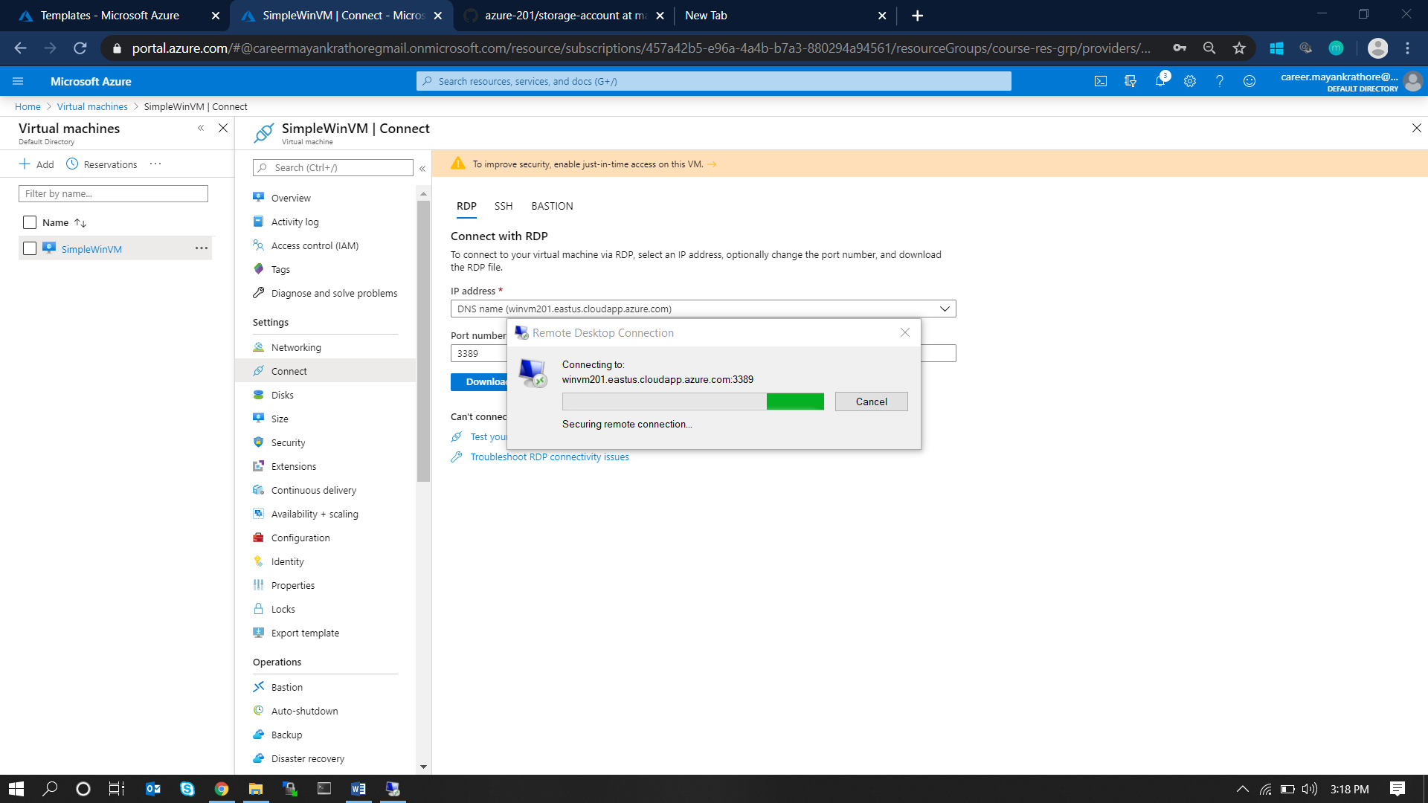

Step #3: Once logged in to the system, configure the system accordingly for the application platform required. Here, I will be using docker so I have docker set-up in the Virtual Machine.

Step #4: Post docker-installation run the below commands in PowerShell to run the application.

**$ docker run –dp 80:80 --name dice-roll-game octopent/js-dice-roll:latest**

Step #5: Application can be accessed at the public IP as shown below.

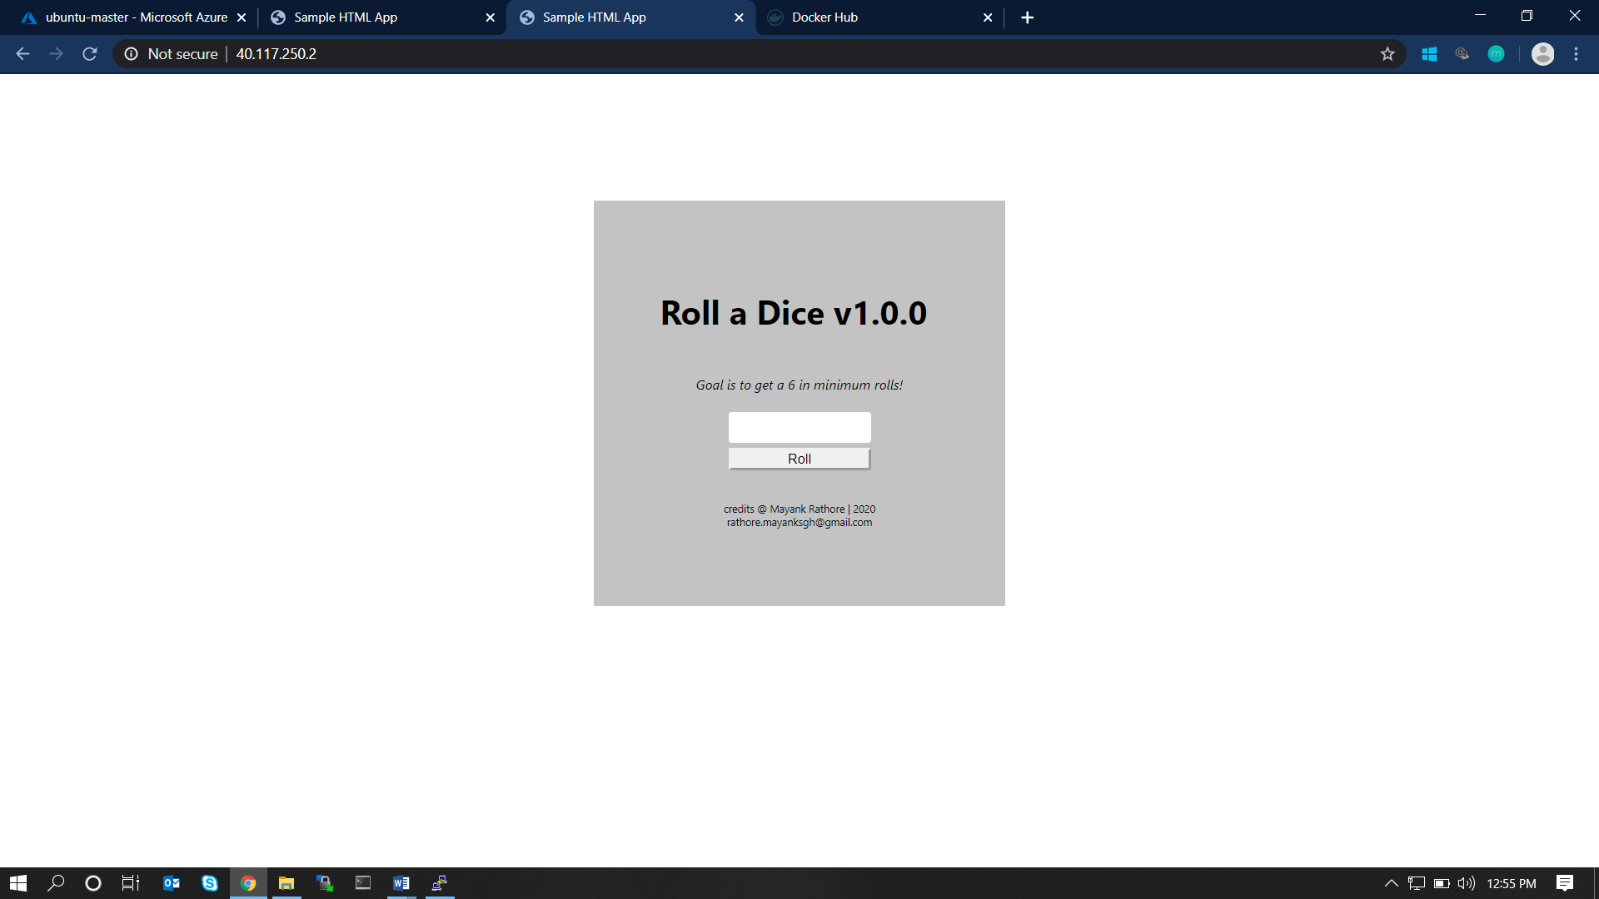

# 3. AZURE APP SERVICES

1. Deploy a HTML Web Application in Azure App Services.

## Steps and Screens

Step #1: Create an Azure App Service from Azure Portal/App Services and configure accordingly.

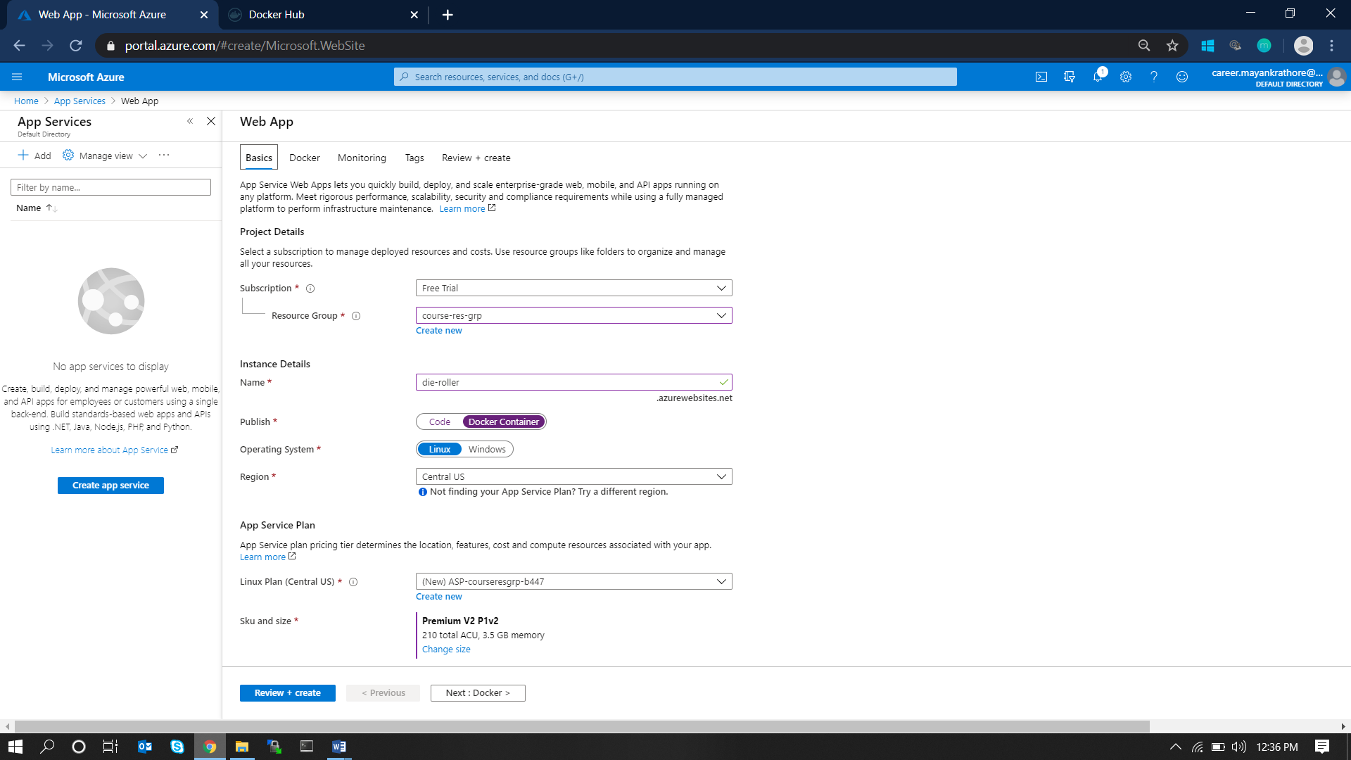

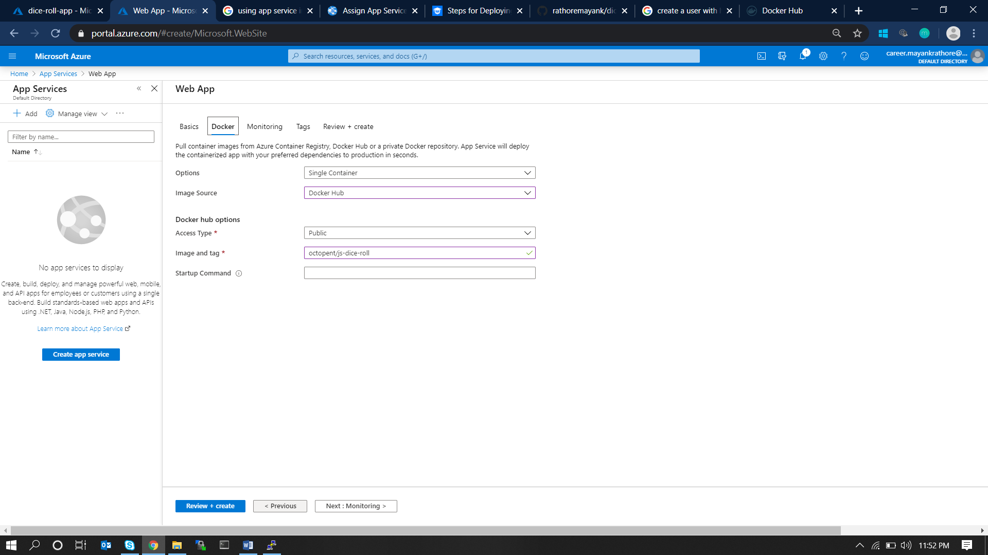

Step #2: Deployment starts as soon as **create** is clicked.

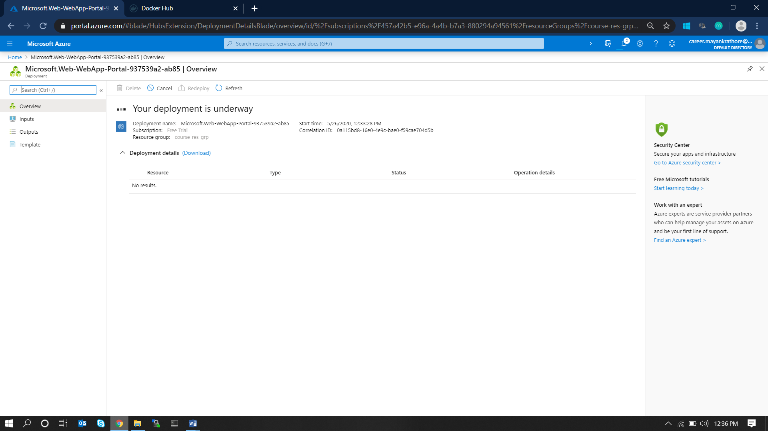

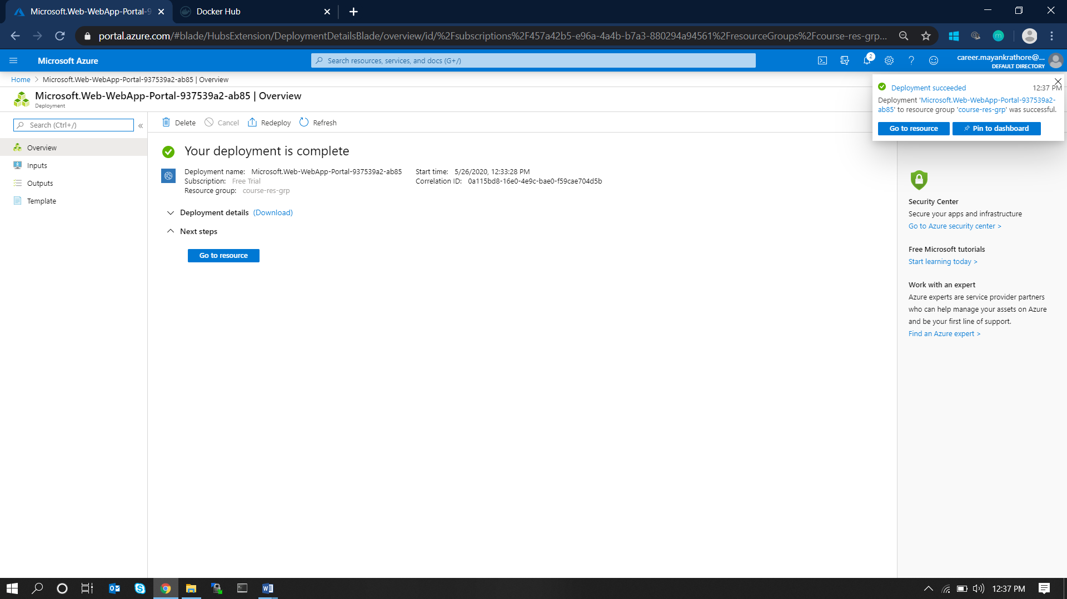

Step #3: Accessing the application: Browse to the app-service and click on the app-service URL (sub-paths if any).

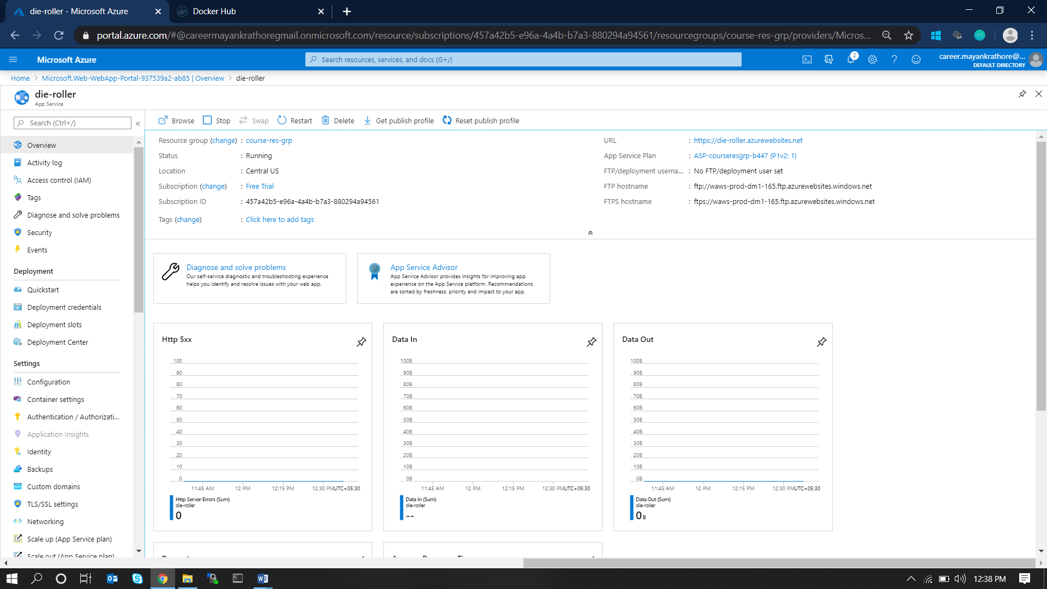

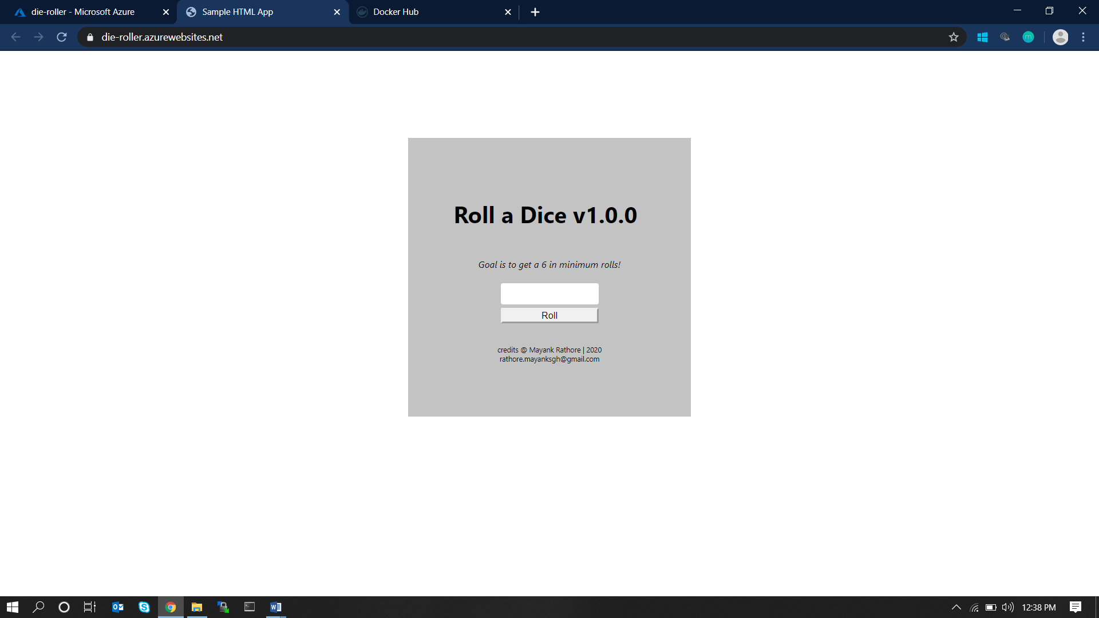

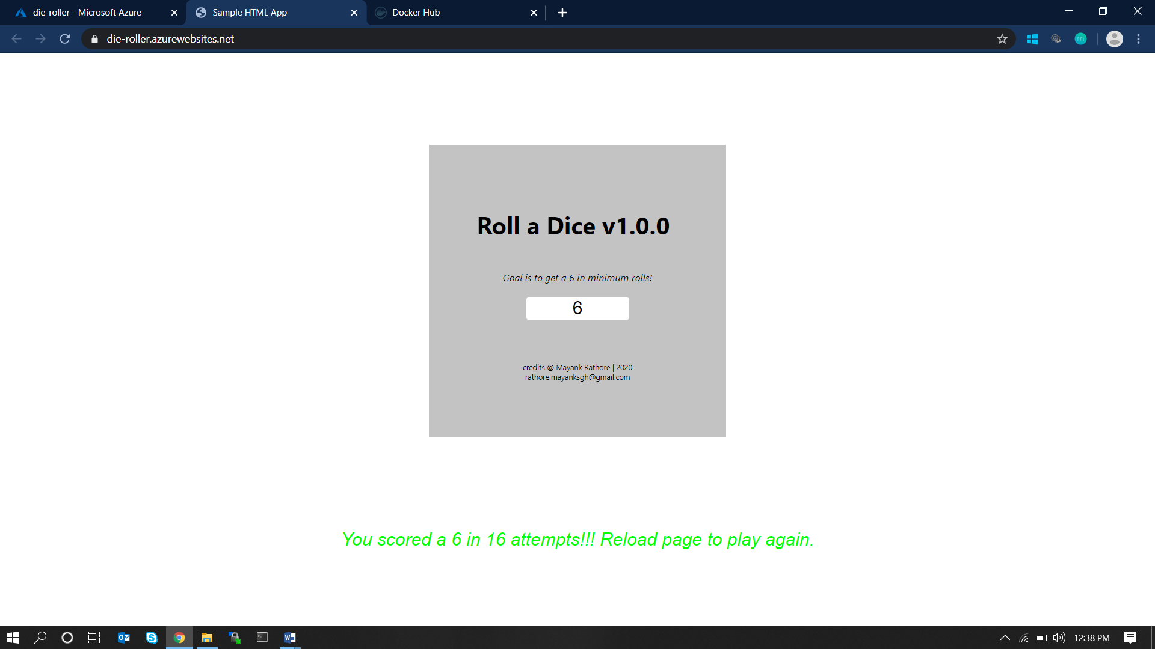

2. Host the App Services in the Virtual Machine deployed.

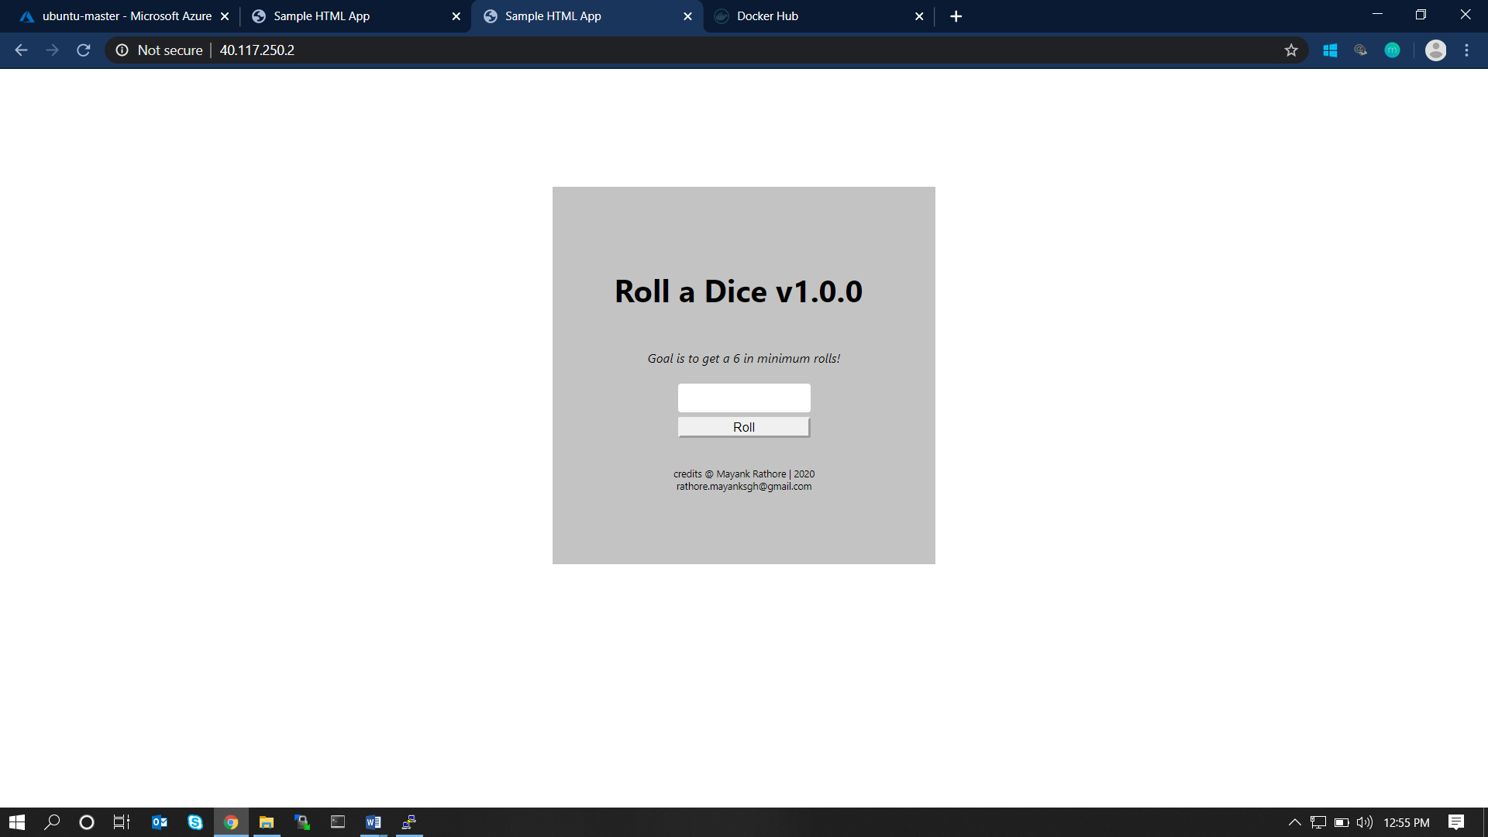

# 4. AZURE FUNCTIONS

1. Write an ARM Template to deploy the azure function along with the code and other required configurations.

## ARM Template

{

    "$schema": "https://schema.management.azure.com/schemas/2015-01-01/deploymentTemplate.json#",

    "contentVersion": "1.0.0.0",

    "parameters": {},

    "variables": {},

    "resources": [

        {

            "type": "Microsoft.Storage/storageAccounts",

            "apiVersion": "2018-07-01",

            "name": "storagefunc",

            "location": "[resourceGroup().location]",

            "tags": {

                "displayName": "storagefunc"

            },

            "sku": {

                "name": "Standard_LRS"

            },

            "kind": "StorageV2"

        },

        {

            "type": "Microsoft.Web/serverfarms",

            "apiVersion": "2018-02-01",

            "name": "servicePlan",

            "location": "[resourceGroup().location]",

            "sku": {

                "name": "S2",

                "tier": "Standard"

            },

            "properties": {

                "name": "servicePlan",

                "computeMode": "Dynamic"

            },

            "tags": {

                "displayName": "servicePlan"

            }

        },

         {

              "apiVersion": "2015-08-01",

              "type": "Microsoft.Web/sites",

              "name": "201functionapp",

              "location": "[resourceGroup().location]",

              "kind": "201functionapp",

              "dependsOn": [

                "[resourceId('Microsoft.Web/serverfarms', 'servicePlan')]",

                "[resourceId('Microsoft.Storage/storageAccounts', 'storagefunc')]"

              ],

              "properties": {

                "serverFarmId": "[resourceId('Microsoft.Web/serverfarms', 'servicePlan')]",

                "siteConfig": {

                  "appSettings": [

                    {

                      "name": "AzureWebJobsDashboard",

                      "value": "[concat('DefaultEndpointsProtocol=https;AccountName=', 'storagefunc', ';AccountKey=', listKeys('storagefunc','2015-05-01-preview').key1)]"

                    },

                    {

                      "name": "AzureWebJobsStorage",

                      "value": "[concat('DefaultEndpointsProtocol=https;AccountName=', 'storagefunc', ';AccountKey=', listKeys('storagefunc','2015-05-01-preview').key1)]"

                    },

                    {

                      "name": "WEBSITE_CONTENTAZUREFILECONNECTIONSTRING",

                      "value": "[concat('DefaultEndpointsProtocol=https;AccountName=', 'storagefunc', ';AccountKey=', listKeys('storagefunc','2015-05-01-preview').key1)]"

                    },

                    {

                      "name": "WEBSITE_CONTENTSHARE",

                      "value": "storagefunc"

                    },

                    {

                      "name": "FUNCTIONS_EXTENSION_VERSION",

                      "value": "~2"

                    },

                    {

                      "name": "FUNCTIONS_WORKER_RUNTIME",

                      "value": "dotnet"

                    }

                  ]

                }

              },

              "resources": [

                  {

                      "apiVersion": "2015-08-01",

                      "name": "web",

                      "type": "sourcecontrols",

                      "dependsOn": [

                        "[resourceId('Microsoft.Web/sites/', '201functionapp')]"

                      ],

                      "properties": {

                          "RepoUrl": "https://github.com/FBoucher/AzUnzipEverything.git",

                          "branch": "master",

                          "publishRunbook": true,

                          "IsManualIntegration": true

                      }

                 }

              ]

            }

    ],

    "outputs": {}

}

## Steps and Screens

Step #1: Creating the template: Browse to Azure Portal/Templates and create a new template. Paste the above JSON Content in it.

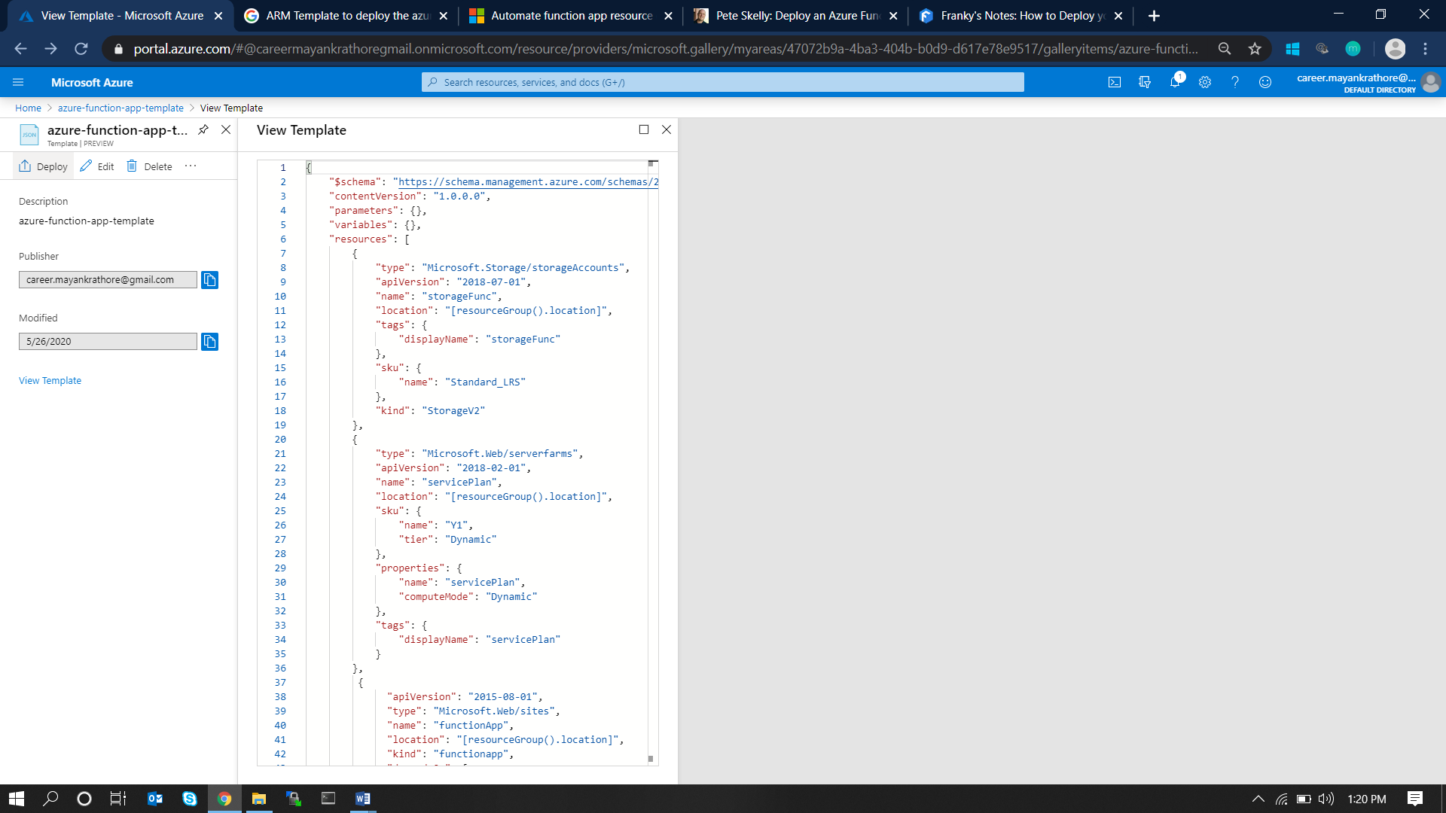

Step #2: Deploy the template: Click on the Deploy button in the left corner. This will lead to the deployment configuration page as below. Fill up the necessary information and click on Purchase.

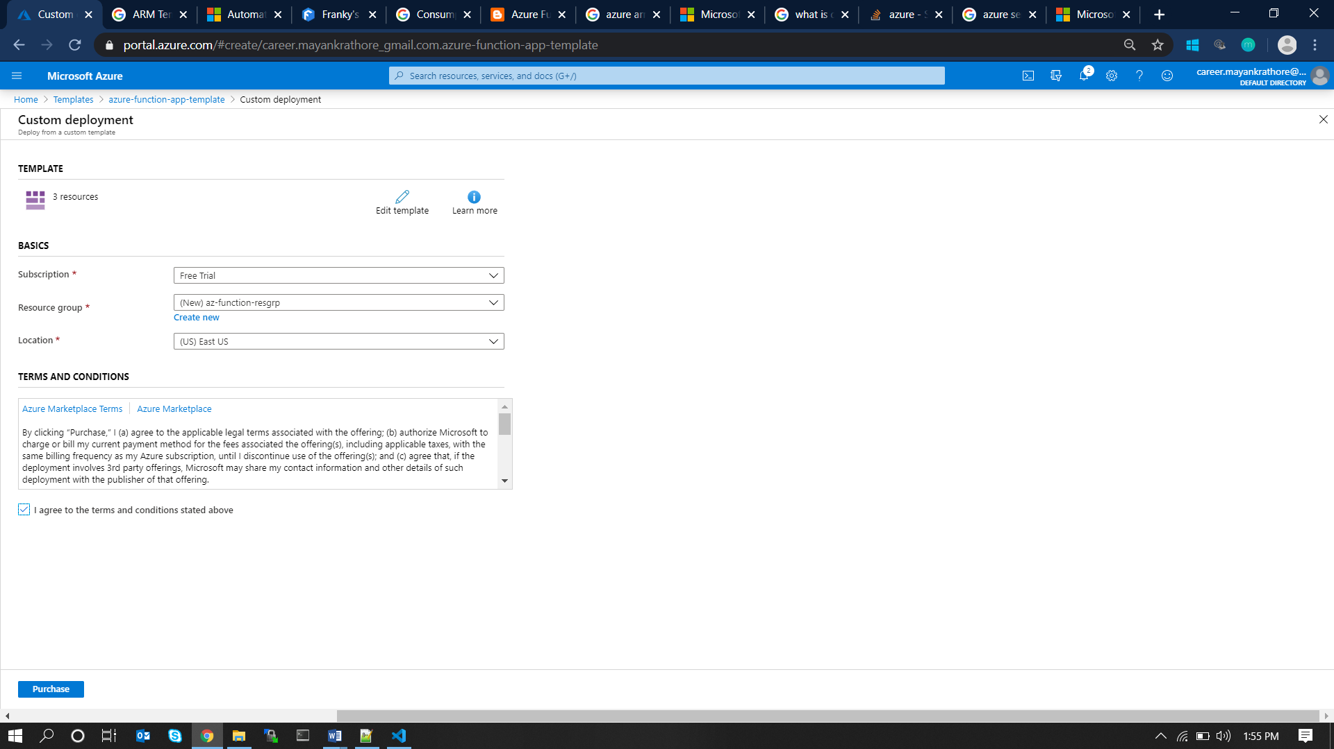

Step #4: Click on the triggered deployment. One by one, all the resources will get created.

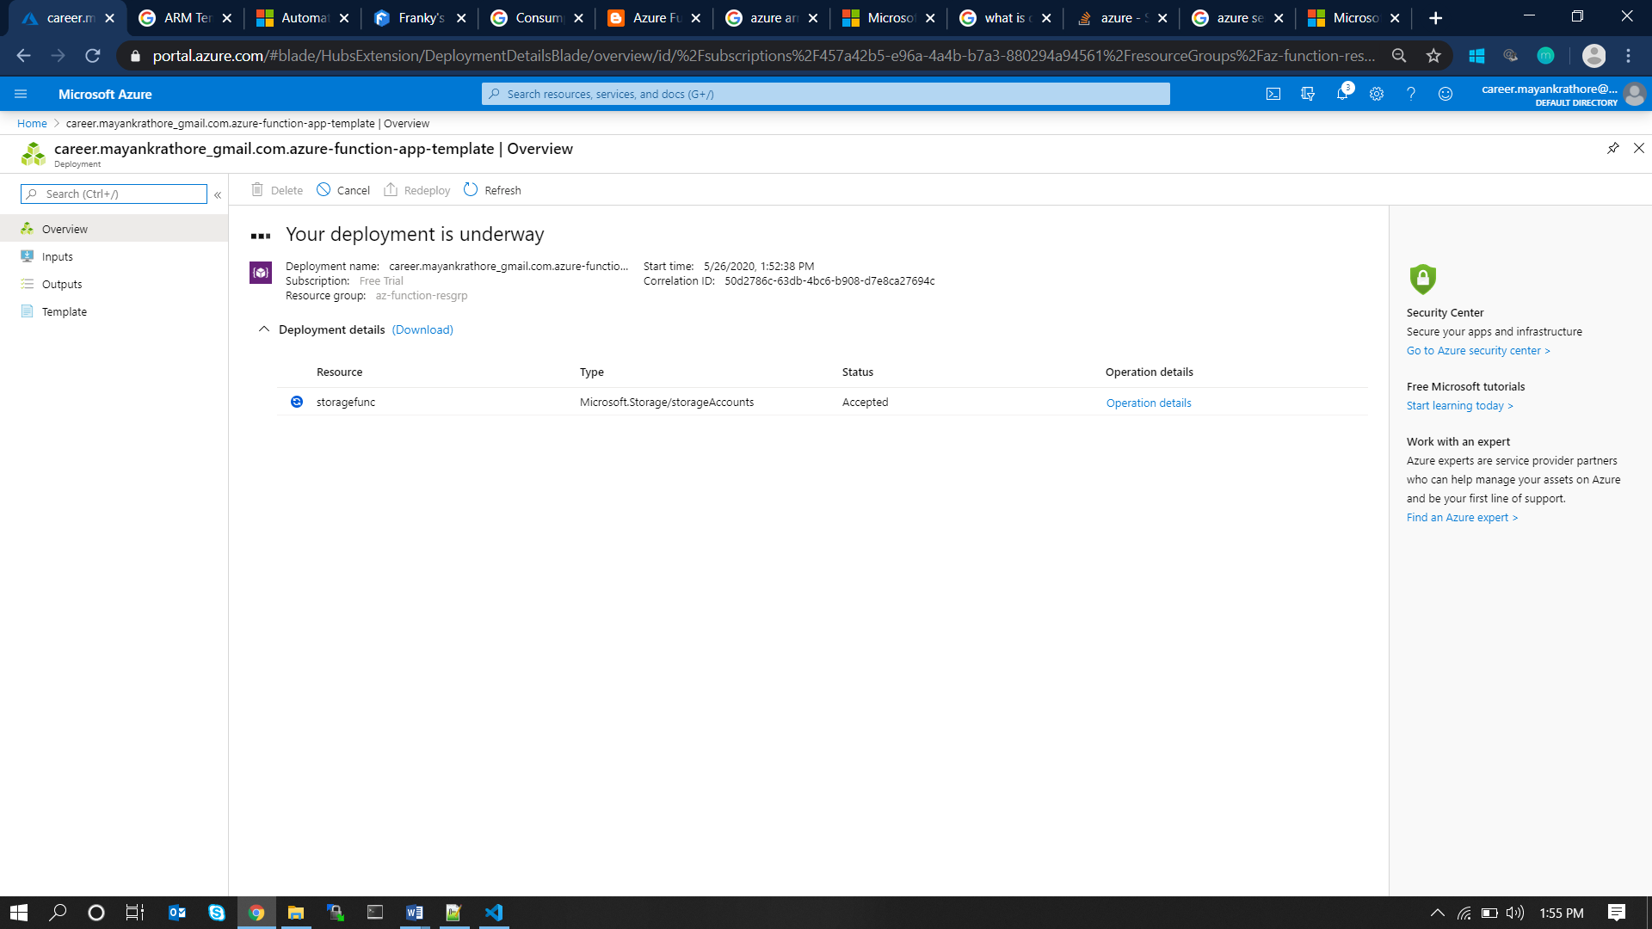

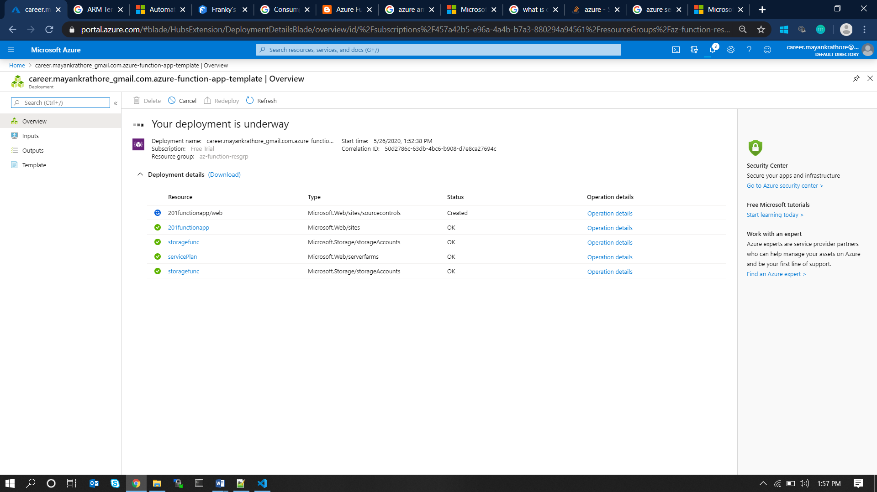

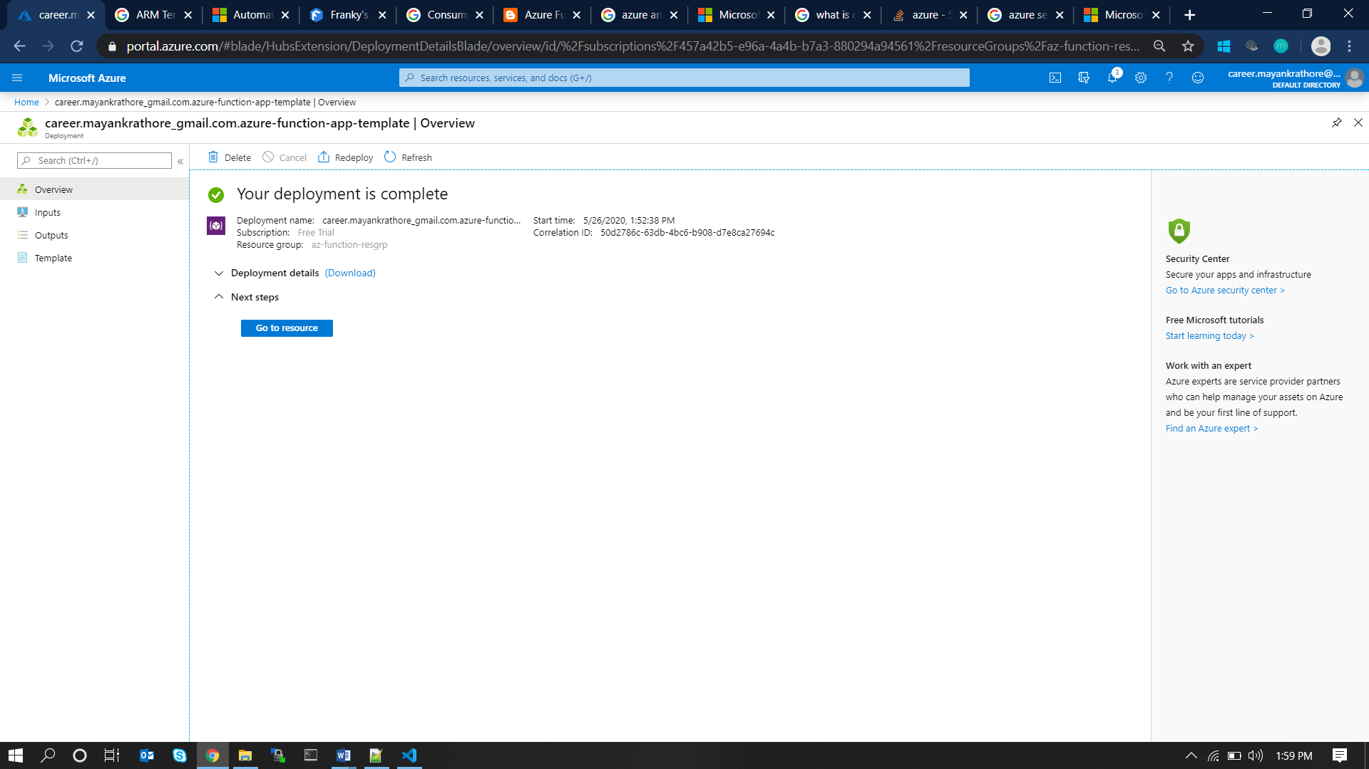

Step #5: Accessing the deployed function: Visit the app service created in the last step and click on the URL.

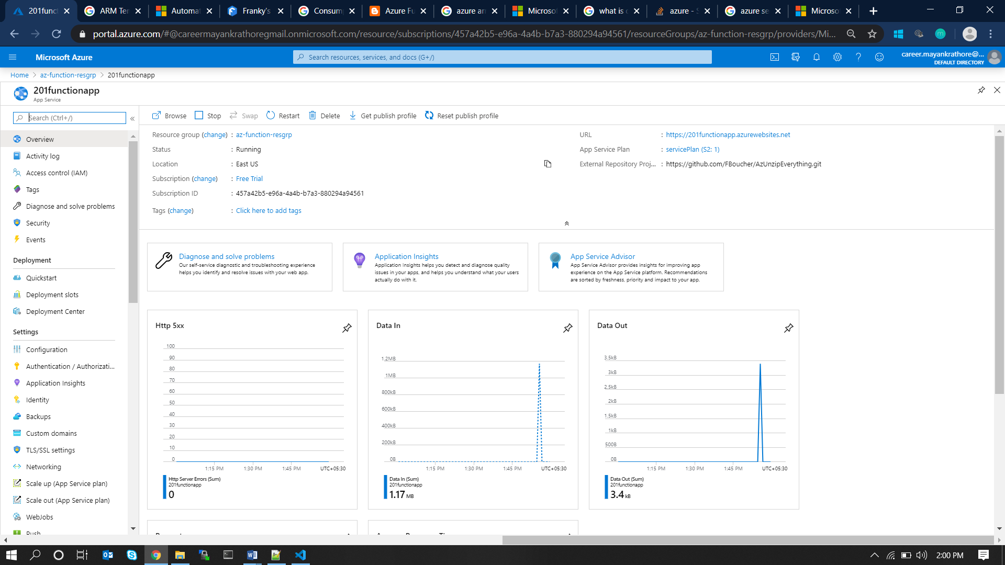

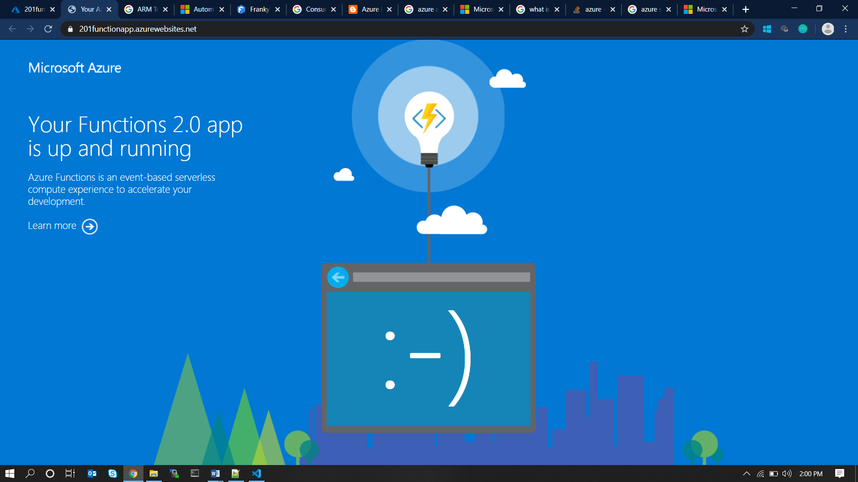

# 5. AZURE COSMOS DB

1. Write an ARM Template to deploy all the Cosmos DBs.

## ARM Template

{

   "$schema": "https://schema.management.azure.com/schemas/2019-04-01/deploymentTemplate.json#",

   "contentVersion": "1.0.0.0",

   "parameters": {

       "accountName": {

           "type": "string",

           "defaultValue": "[concat('cosmos-', uniqueString(resourceGroup().id))]",

           "metadata": {

               "description": "Cosmos DB account name"

           }

       },

       "location": {

           "type": "string",

           "defaultValue": "[resourceGroup().location]",

           "metadata": {

               "description": "Location for the Cosmos DB account."

           }

       },

       "databaseName": {

           "type": "string",

           "metadata": {

               "description": "The name for the Core (SQL) database"

           }

       }

   },

   "variables": {

       "accountName": "[toLower(parameters('accountName'))]"

   },

   "resources": [

       {

           "type": "Microsoft.DocumentDB/databaseAccounts",

           "apiVersion": "2020-03-01",

           "name": "[parameters('accountName')]",

           "location": "[parameters('location')]",

           "properties": {

               "enableFreeTier": true,

               "databaseAccountOfferType": "Standard",

               "consistencyPolicy": {

                   "defaultConsistencyLevel": "Session"

               }

           }

       },

       {

           "type": "Microsoft.DocumentDB/databaseAccounts/sqlDatabases",

           "apiVersion": "2020-03-01",

           "name": "[concat(variables('accountName'), '/', parameters('databaseName'))]",

           "dependsOn": [ "[resourceId('Microsoft.DocumentDB/databaseAccounts', variables('accountName'))]" ],

           "properties": {

               "resource": {

                   "id": "[parameters('databaseName')]"

               },

               "options": {"throughput": 400}

           }

       }

   ]

}

Step #1: Creating the template: Browse to **Azure Portal/Templates** and create a new template. Paste the above JSON Content in it.

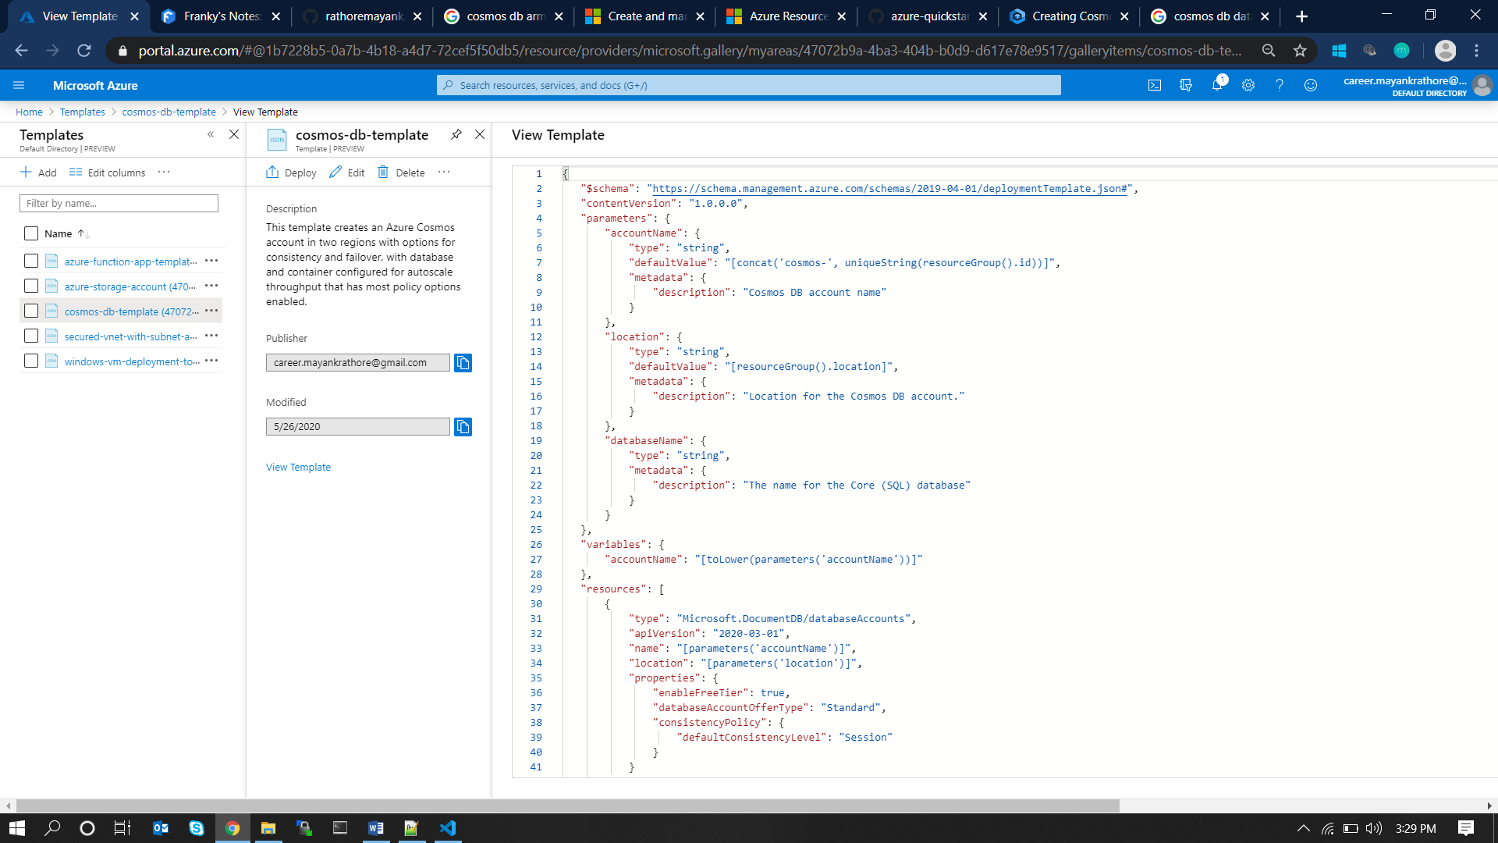

Step #2: Deploy the template: Click on the Deploy button in the left corner. This will lead to the deployment configuration page as below. Fill up the necessary information and click on Purchase.

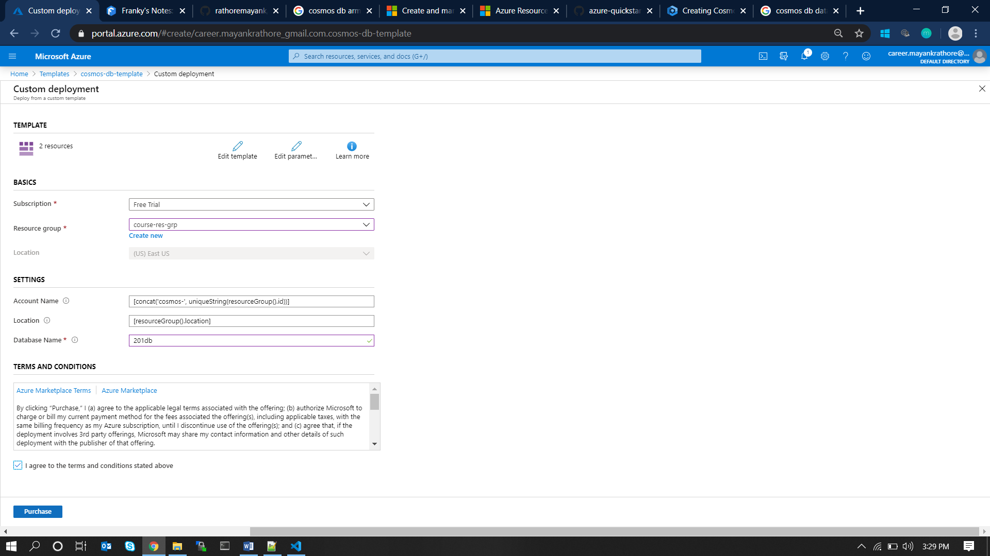

Step #3: Accessing the cosmos db. Once the deployment is complete, click on the Go to Resource Button.

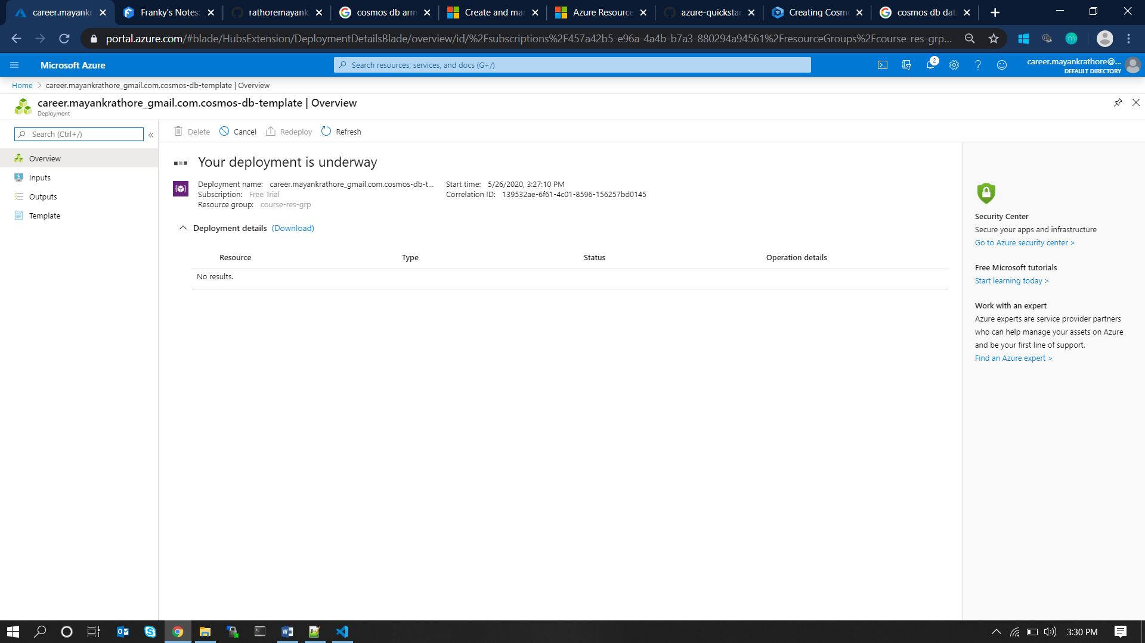

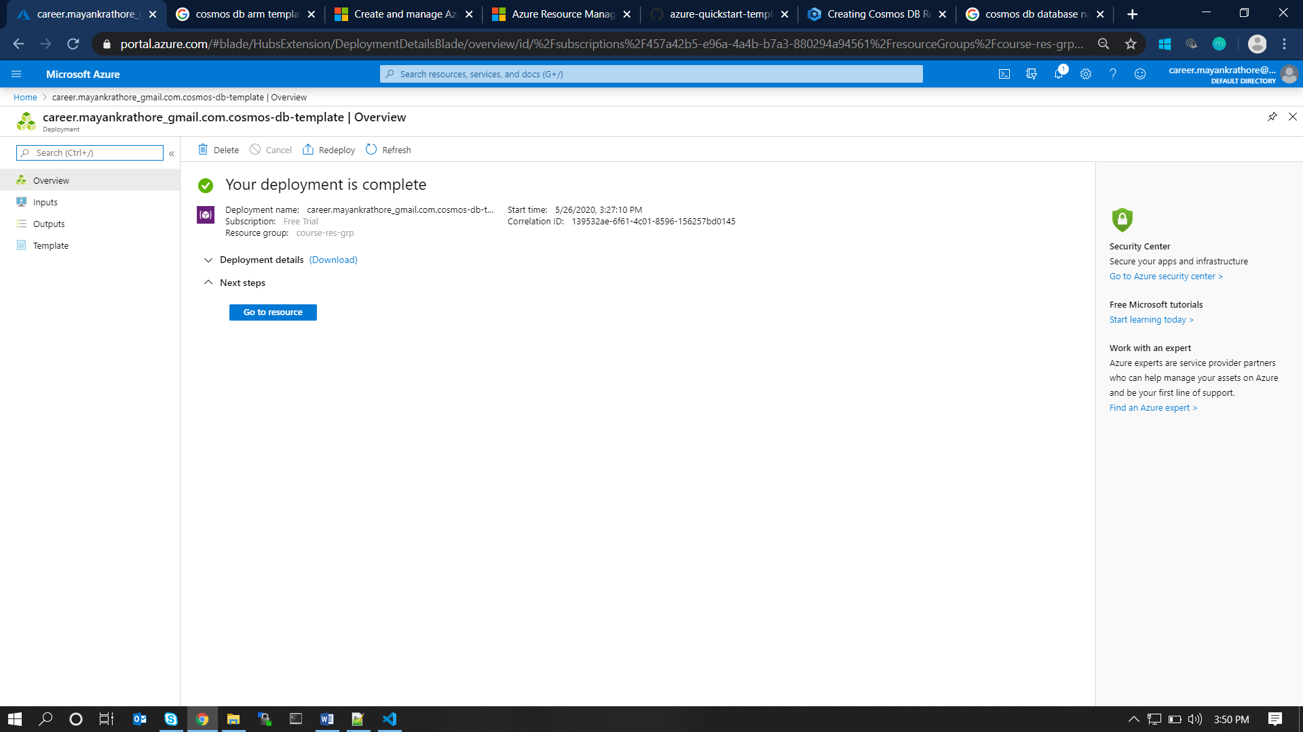

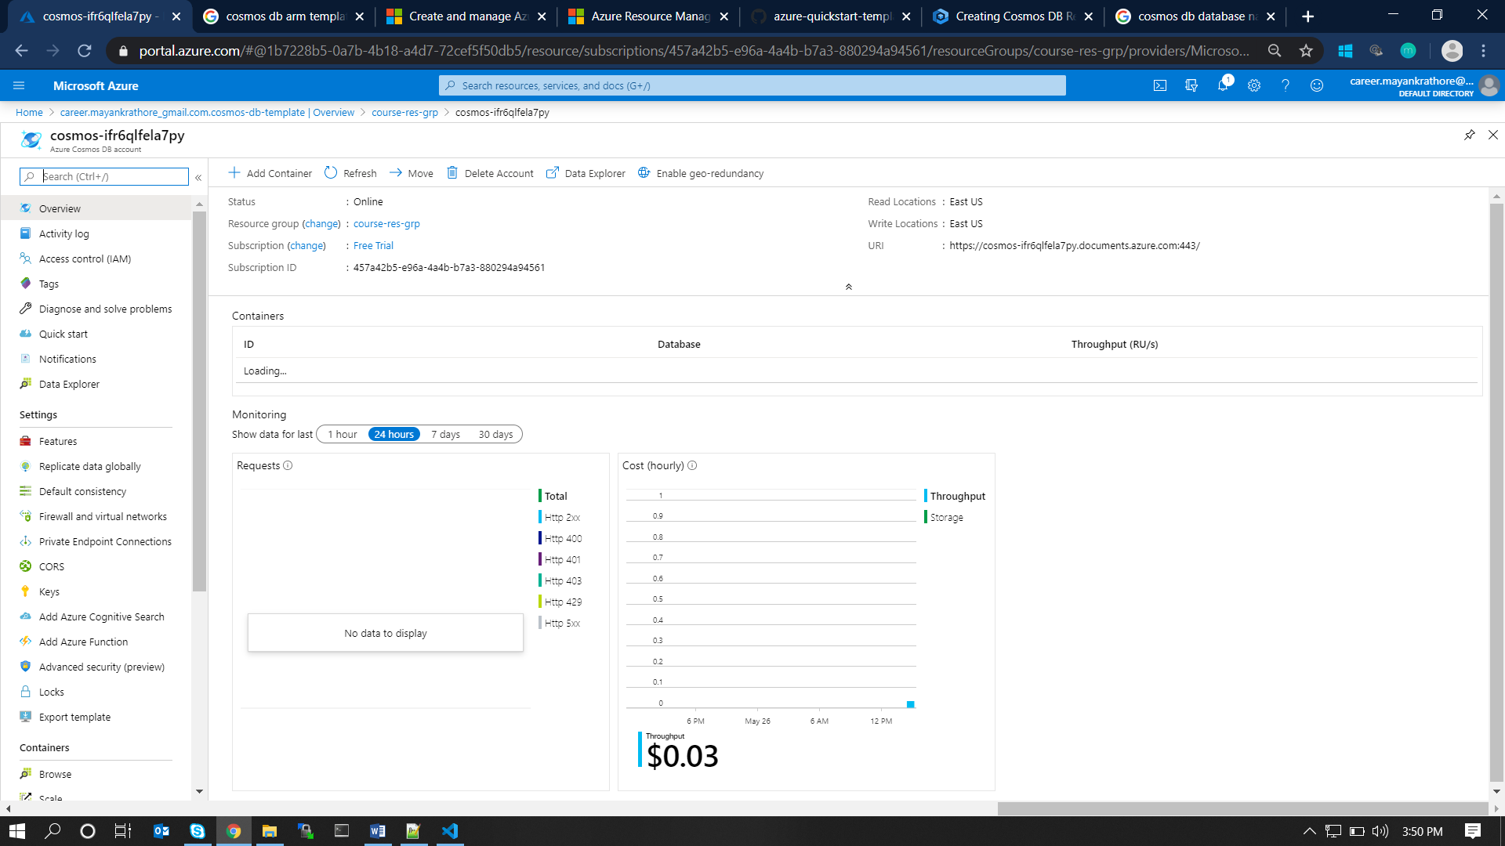

Step #4: Cosmos DB is ready to use and configured further at **Azure Portal/Cosmos DB** as below.

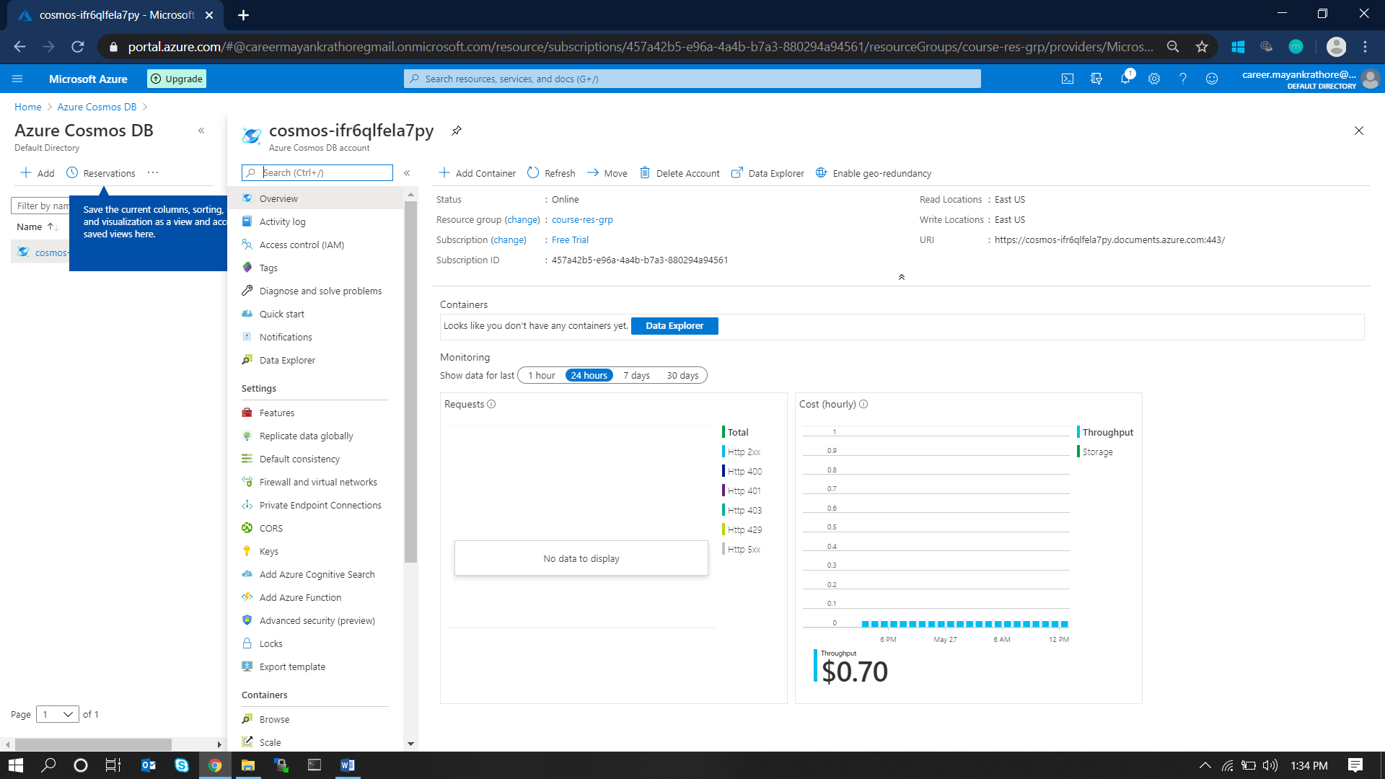

# 6. BIBLIOGRAPHY

## **References**

Azure Documentation:

[**https://docs.microsoft.com/en-us/azure/?product=featured**](https://docs.microsoft.com/en-us/azure/?product=featured)

## **Project Source Code**

Project Source Code is available at below URL:

<https://github.com/rathoremayank/azure-201>